
Arab Academy for Science, Technology and Maritime Transport
College of Computing and Information Technology

B. Sc. Final Year Project

An Ai tool for image based breast cancer early detection
(BreastCare AI)
Presented By:

Omar Khaled shaker (CS) | Omar Mahrous (IS)
Seif Mohamed (SE) | Youssef Abdullah (AI)
Mohammed Karim (AI) Moemen Ayman (SE)

Supervised By:
Dr. Hanan Ali

June– 2026

ACKNOWLEDGMENT
We would like to express our sincere gratitude to our supervisor Dr. Hanan Ali for her continuous guidance, encouragement, and valuable feedback throughout the development of this graduation project.
Their expertise, support, and constructive suggestions greatly contributed to the successful completion of this work. We are deeply thankful for the time and effort she dedicated to helping us overcome technical and research challenges.
We would also like to thank the faculty members of the College of Computing and Information Technology for providing us with the knowledge and academic foundation necessary to undertake this project.
Special thanks are extended to our families and friends for their patience, understanding, and unwavering support during the entire project period.
Finally, we acknowledge all researchers and organizations that made publicly available breast cancer datasets and scientific publications, which played an essential role in the training, testing, and evaluation of our system.
This project would not have been possible without the support and contributions of all those mentioned above.

ABSTRACT
Breast cancer is one of the most common cancers affecting women worldwide and remains a leading cause of cancer-related deaths. Early detection significantly improves treatment outcomes and survival rates. Mammography is considered one of the most effective screening methods; however, manual interpretation of mammograms can be time-consuming and subject to human error.
This project presents BreastCare AI, an intelligent web-based system designed to assist healthcare professionals in the detection and analysis of breast abnormalities using artificial intelligence techniques. The proposed system integrates deep learning models with a modern web platform to provide automated mammogram analysis, classification, and similarity-based case retrieval.
The system employs a YOLO-based deep learning model trained on breast ultrasound and mammography datasets to identify suspicious regions and classify images into benign, malignant, or normal categories. In addition, an embedding-based similarity search mechanism is implemented using deep feature extraction techniques to retrieve visually similar medical cases from a large database, providing additional diagnostic support.
The platform consists of a React frontend, a FastAPI backend, and a PostgreSQL database for secure storage and management of patient records, medical reports, mammogram images, AI-generated results, and audit logs. The system supports multiple user roles, including hospitals, patients, and administrators, enabling secure access to medical data and system management functionalities.

List of tables
Table 1Comparison of Breast Imaging Datasets 25
Table 2 Comparison Between Machine Learning and Deep Learning 28
Table 3 Evolution of YOLO Models 34
Table 4 Main Database Tables 59
Table 5 Software Environment 74
Table 6 Comparison of Breast Imaging Datasets Used in This Study 86
Table 7 YOLOv8 Training Configuration 94
Table 8 Training Workflow 97
Table 9 Evaluation Metrics Used in This Study 104
Table 10 computational environment used throughout the experiments. 107
Table 11 summary for the CBIS-DDSM training results. 108
Table 12 summary for the BUSI experimental results. 109
Table 13 summary for the Kaggle dataset results. 110
Table 14 Similarity Search Evaluation 115
Table 15 evaluation of funtional modules 116
Table 16 tested endpoints 118
Table 17 Overall System Testing Summary 121

List of figures
Figure 1 Content-Based Image Retrieval (CBIR) 40
Figure 2 Use Case 1: User Login 52
Figure 3 Use Case 2: Upload Mammogram 53
Figure 4 Use Case 3: AI Analysis 54
Figure 5 Use Case 4: Similarity Search 55
Figure 6 Use Case 5: Medical Report Generation 56
Figure 7 Use Case 6: System Administration 57
Figure 8 Entity Relationship Diagram (ERD) 63
Figure 9 Data Flow Diagram (DFD) 63
Figure 10 System Flowcharts 64
Figure 11 Home Page UI 65
Figure 12 Login and Registration UI 66
Figure 13 Hospital Dashboard UI 67
Figure 14 Patient Dashboard 68
Figure 15 Upload Page UI 69
Figure 16 AI Analysis Report UI 70
Figure 17 Report Page UI 71
Figure 18 Admin Dashboard UI 72
Figure 19 Sample images from the BUSI dataset (Normal, Benign, and Malignant). 88
Figure 20 Example images from the Kaggle YOLO breast ultrasound dataset with bounding box annotations 88
Figure 21 Example mammograms from the CBIS-DDSM dataset. 89
Figure 22 Illustration of YOLO Loss Components When the Detection Model Produces Correct Predictions 106
Figure 23 Visualization of Box Loss, Classification Loss, and Distribution Focal Loss (DFL) for Incorrect Object Detection 107

Contents
ACKNOWLEDGMENT 2
ABSTRACT 3
List of tables 4
List of figures 5
CHAPTER 1: INTRODUCTION 13
1.1 Background 14
1.2 Problem Statement 15
1.3 Project Aim 16
1.4 Project Objectives 16
1.5 Scope of the Project 17
1.6 Challenges and Limitations 17
1.7 Health, Safety and Ethical Considerations 18
CHAPTER 2: LITERATURE REVIEW 19
2.1 Breast Cancer Overview 20
2.2 Mammography and Breast Imaging 21
2.2.1 Mammography 21
2.2.2 Breast Ultrasound Imaging 22
2.2.3 Breast Ultrasound Images (BUSI) Dataset 23
2.2.4 CBIS-DDSM Dataset 23
2.2.5 Kaggle Breast Ultrasound Dataset 24
2.2.6 Comparison of Breast Imaging Datasets 24
2.2.7 Importance of Breast Imaging in AI-Based Diagnosis 25
2.3 Artificial Intelligence in Medical Imaging 25
2.3.1 Artificial Intelligence in Healthcare 26
2.3.2 Computer-Aided Diagnosis (CAD) 26
2.3.3 Artificial Intelligence in Breast Cancer Diagnosis 27
2.3.4 Machine Learning versus Deep Learning 27
2.3.5 Advantages of AI in Medical Imaging 28
2.3.6 Challenges of AI in Medical Imaging 29
2.3.7 Artificial Intelligence in the Proposed BreastCare AI System 29
2.4 Deep Learning for Breast Cancer Detection 30
Image Classification 30
Object Detection 31
Image Segmentation 31
Transfer Learning 32
Challenges of Deep Learning 32
2.5 YOLO-Based Detection Models 32
2.5.1 Experimental Comparison of YOLO Models 33
2.5.2 Dataset Comparison 34
Kaggle YOLO Breast Ultrasound Dataset 36
2.5.3 Selection of YOLOv8 for the Proposed System 37
2.5.4 Summary of Dataset Selection 37
2.6 Image Embedding and Similarity Search 38
2.6.1 Image Embeddings 39
2.6.2 Deep Feature Extraction Using ResNet18 40
2.6.3 Feature Vector Representation 40
2.6.4 Cosine Similarity 41
2.6.5 Similarity Search Pipeline 42
2.6.6 Clinical Importance of Similarity Search 42
2.6.7 Similarity Search in the Proposed BreastCare AI System 43
CHAPTER 3: SYSTEM ANALYSIS AND REQUIREMENTS 44
3.1 Existing System Analysis 45
3.2 Proposed System 46
3.3 Functional Requirements 46
3.4 Non-Functional Requirements 48
3.5 User Roles and Permissions 49
3.6 Use Case Analysis 51
CHAPTER 4: SYSTEM DESIGN 57
4.1 Overall System Architecture 58
4.2 Database Design 59
Main Database Tables 59
4.3 Entity Relationship Diagram (ERD) 60
Main Relationships 60
4.4 Data Flow Diagram (DFD) 62
4.5 System Flowcharts 63
4.6 User Interface Design 64
Main Screens 64
4.7 Security Design 72
Authentication 72
Authorization 72
Data Protection 72
Audit Trail 72
CHAPTER 5: IMPLEMENTATION AND METHODOLOGY 73
5.1 Development Environment 74
Hardware Environment 74
Software Environment 74
5.2 Frontend Implementation (React) 75
Main Components 75
React Features Used 75
Frontend Workflow 75
5.3 Backend Implementation (FastAPI) 76
Backend Responsibilities 76
API Structure 76
API Communication 77
5.4 Database Implementation (PostgreSQL) 77
Database Tables 77
Database Features 77
5.5 Authentication and Authorization 78
Login Process 78
User Roles 78
Authorization 78
Security Measures 78
5.6 AI Detection Model 79
Dataset 79
Model Architecture 79
Output Classes 79
AI Pipeline 79
5.7 Similarity Search System 80
Process 80
Similarity Metric 80
Output 80
5.8 Medical Report Generation 81
Report Components 81
Workflow 81
5.9 Administration and Audit Logging 82
Administrative Functions 82
Audit Logs 82
Logged Information 82
5.10 Version Control and Collaboration 83
Git Workflow 83
Benefits 83
CHAPTER 6: TESTING AND EVALUATION 84
6.1 Dataset Description 85
Comparison of Breast Imaging Datasets Used in This Study 86
6.2 Data Preprocessing 89
6.2.1 Dataset Organization 89
6.2.2 Image Resizing 89
6.2.3 Image Normalization 90
6.2.4 Data Annotation 90
6.2.5 Feature Extraction Preprocessing 91
6.2.6 Embedding Database Preparation 91
6.2.7 Preprocessing Workflow 91
6.3 Model Training 92
6.3.1 Training Environment 92
6.3.2 Dataset Preparation 93
6.3.3 Hyperparameter Configuration 93
6.3.4 Optimization Strategy 94
6.3.5 Training Monitoring 95
6.3.6 Selection of the Final Model 95
6.3.7 Integration with the Proposed System 96
6.4 Performance Metrics 97
6.4.1 Accuracy 97
6.4.2 Precision 98
6.4.3 Recall (Sensitivity) 98
6.4.4 F1-Score 99
6.4.5 Mean Average Precision (mAP) 99
6.4.6 Intersection over Union (IoU) 100
6.4.7 Confidence Score 101
6.4.8 Class Probability Distribution 101
6.4.9 Cosine Similarity 102
6.4.10 Confusion Matrix 103
6.4.11 Summary of Evaluation Metrics 104
6.5 Detection Results 107
6.5.1 Experimental Environment 107
6.5.2 CBIS-DDSM Experimental Results 108
6.5.3 BUSI Experimental Results 108
6.5.4 Kaggle YOLOv8 Dataset Results 109
6.5.5 Comparative Analysis 110
6.5.6 Final Model Selection 110
6.6 Similarity Search Results 113
6.6.1 Similarity Search Workflow 114
6.6.2 Embedding Generation 114
6.6.3 Similarity Computation 115
6.6.4 Similarity Database 115
6.6.5 Experimental Results 116
6.6.6 Clinical Significance 117
6.6.7 Limitations 117
6.6.8 Summary 118
6.7 System Testing 118
6.7.1 Testing Objectives 119
6.7.2 Functional Testing 119
6.7.3 Database Testing 120
6.7.4 API Testing 121
6.7.5 AI Workflow Testing 121
6.7.6 Authentication and Security Testing 122
6.7.7 Performance Testing 123
6.7.8 Summary of System Testing 123
CHAPTER 7: CONCLUSION AND FUTURE WORK 125
7.1 Conclusion 126
7.2 Project Contributions 127
7.3 Future Enhancements 128
REFERENCES 130

CHAPTER 1: INTRODUCTION

Background

Breast cancer is one of the most common cancers affecting women worldwide and remains a leading cause of cancer-related deaths. Early detection significantly improves treatment outcomes and survival rates. Mammography is considered the primary screening method for breast cancer; however, interpreting mammogram images requires highly trained radiologists and can be time-consuming and prone to human error. Recent advances in Artificial Intelligence (AI), Machine Learning (ML), and Deep Learning (DL) have demonstrated significant potential in assisting medical professionals by automatically detecting suspicious lesions and classifying breast abnormalities with high accuracy.
This project presents BreastCare AI, an intelligent web-based system designed to support breast cancer diagnosis through automated mammogram analysis. The system integrates deep learning models for lesion detection, classification, and similarity search while providing healthcare professionals with a centralized platform for patient management, medical records, and AI-assisted reporting.

Problem Statement

Breast cancer diagnosis through mammography often depends on the experience and workload of radiologists. Manual interpretation of mammograms may lead to missed abnormalities, false positives, delayed diagnosis, and increased healthcare costs. Additionally, healthcare institutions may lack efficient tools for storing, analyzing, and comparing mammogram images with previous cases.
Therefore, there is a need for an intelligent system capable of automatically analyzing mammogram images, identifying suspicious regions, classifying findings, retrieving similar historical cases, and assisting radiologists in generating comprehensive diagnostic reports.

Project Aim

The aim of this project is to develop an AI-powered web-based breast cancer diagnostic support system that assists radiologists in analyzing mammogram images, detecting abnormalities, classifying breast lesions, retrieving similar cases, and generating diagnostic reports to improve the efficiency and accuracy of breast cancer screening.

Project Objectives
The main objectives of this project are:
• Develop a secure web-based platform for breast cancer screening and management.
• Implement a deep learning model for breast lesion detection.
• Classify mammogram images into Normal, Benign, or Malignant categories.
• Generate confidence scores and probability distributions for AI predictions.
• Provide similarity search functionality using image embeddings.
• Store patient information, medical records, mammogram images, and AI reports in a centralized database.
• Allow radiologists to review AI findings and generate final medical reports.
• Provide administrators with tools to monitor system activity, logs, and users.
• Improve diagnostic support and reduce radiologists’ workload.

Scope of the Project

The project focuses on developing an intelligent diagnostic support platform for breast cancer screening using mammogram images. The system includes user authentication, patient management, hospital management, image upload, AI-powered lesion detection and classification, similarity search, medical reporting, and administrative monitoring.
The project does not replace radiologists or provide final medical diagnoses. Instead, it serves as a decision-support tool to assist healthcare professionals in identifying potentially suspicious findings and reviewing similar historical cases.

Challenges and Limitations

Several challenges were encountered during the development of the project, including:
• Obtaining and preparing high-quality annotated medical datasets.
• Managing class imbalance between benign, malignant, and normal images.
• Training deep learning models with limited computational resources.
• Ensuring secure storage of sensitive medical data.
• Integrating AI models with the web application and database systems.
• Maintaining reliable similarity search performance across large image datasets.
The system also has limitations, including dependency on dataset quality, potential prediction errors, and the need for expert medical validation of AI-generated results.

Health, Safety and Ethical Considerations

Healthcare applications involving medical data must comply with ethical and privacy requirements. This project considers the following aspects:
• Protection of patient privacy and confidentiality.
• Secure storage and transmission of medical information.
• Restricted access through authentication and authorization mechanisms.
• Transparency regarding AI-generated predictions.
• Human oversight by qualified radiologists before making medical decisions.
• Prevention of misuse of medical data and unauthorized access.
The system is intended as a clinical decision-support tool and not as a replacement for professional medical judgment.

CHAPTER 2: LITERATURE REVIEW

2.1 Breast Cancer Overview
Breast cancer is one of the most prevalent cancers affecting women worldwide and remains one of the leading causes of cancer-related mortality [1], [2]. According to the World Health Organization (WHO), more than 2.3 million women were diagnosed with breast cancer in 2022, making it the most frequently diagnosed cancer globally [1]. Early detection significantly improves survival rates, with the five-year survival rate exceeding 90% when the disease is diagnosed during its initial stages [2].
Breast cancer develops when abnormal cells within breast tissue begin to grow uncontrollably. These cells may invade surrounding tissues and eventually metastasize to distant organs if left untreated [2]. Although breast cancer can affect both women and men, approximately 99% of reported cases occur in women [1].
Several factors contribute to breast cancer development, including increasing age, inherited genetic mutations such as BRCA1 and BRCA2, hormonal influences, obesity, alcohol consumption, family history, and prolonged exposure to estrogen [2], [3]. Nevertheless, a considerable proportion of patients develop breast cancer despite having no identifiable risk factors [2].
The most common pathological types of breast cancer include:
- Ductal Carcinoma In Situ (DCIS)
- Invasive Ductal Carcinoma (IDC)
- Invasive Lobular Carcinoma (ILC)
- Triple-Negative Breast Cancer (TNBC)
- HER2-positive Breast Cancer [2], [4]
Clinical symptoms may include breast lumps, nipple discharge, breast pain, skin thickening, or changes in breast shape [2]. However, many patients remain asymptomatic during the early stages of the disease, highlighting the importance of routine screening programs [1], [2].
Early diagnosis is widely recognized as the most effective strategy for reducing breast cancer mortality [1], [2]. Modern screening programs rely heavily on medical imaging technologies combined with Computer-Aided Diagnosis (CAD) systems that assist radiologists in identifying suspicious lesions before clinical symptoms appear [5].
Recent advances in Artificial Intelligence (AI), particularly deep learning, have demonstrated remarkable success in improving breast cancer screening accuracy, reducing diagnostic variability, and assisting clinicians in making more informed decisions [6]–[8].

2.2 Mammography and Breast Imaging
Breast imaging plays a fundamental role in the early detection, diagnosis, and management of breast cancer. Medical imaging allows clinicians to visualize abnormalities within breast tissue before they become clinically apparent, thereby improving treatment outcomes and reducing mortality [1], [2]. Over the past several decades, multiple imaging modalities have been developed to assist physicians in identifying suspicious breast lesions, each possessing distinct advantages and limitations depending on the patient's clinical condition, breast density, and age [9], [10].
The most widely used breast imaging modalities include mammography, ultrasound, magnetic resonance imaging (MRI), and digital breast tomosynthesis (DBT). These techniques are frequently used together to provide complementary diagnostic information, enabling radiologists to improve diagnostic confidence and reduce unnecessary biopsies [9], [10].

2.2.1 Mammography
Mammography is considered the gold standard for breast cancer screening and is the primary imaging modality recommended by healthcare organizations worldwide for the early detection of breast cancer [1], [2]. It utilizes low-dose X-rays to produce high-resolution images of breast tissue, allowing radiologists to detect masses, architectural distortions, and microcalcifications that may indicate malignant disease [9].
Routine mammographic screening has significantly reduced breast cancer mortality through the early identification of tumors before they become palpable. Numerous clinical studies have demonstrated that regular mammography screening programs substantially increase survival rates among women aged 40 years and older [1], [9].
Despite its clinical importance, mammography presents several challenges. Dense breast tissue often appears similar to tumors on X-ray images, making lesion detection difficult even for experienced radiologists [10]. Furthermore, mammographic images typically possess very high spatial resolutions, often exceeding 3000 × 4800 pixels, which increases computational complexity when developing deep learning models [11].
Another challenge involves the presence of extremely small lesions that may occupy only a tiny portion of the image. During preprocessing, images are usually resized to accommodate neural network input dimensions, potentially causing the loss of subtle diagnostic details [11].
Because of these limitations, researchers have explored complementary imaging modalities capable of providing additional diagnostic information.

2.2.2 Breast Ultrasound Imaging
Breast ultrasound is one of the most widely used complementary imaging techniques for evaluating suspicious breast abnormalities detected during mammographic screening [10]. Unlike mammography, ultrasound uses high-frequency sound waves rather than ionizing radiation to generate real-time images of breast tissue, making it particularly suitable for younger women and patients with dense breast tissue [12].
Ultrasound imaging offers several advantages over mammography:
- It does not expose patients to ionizing radiation.
- It provides real-time imaging.
- It distinguishes cystic lesions from solid masses.
- It performs well in dense breast tissue.
- It is relatively inexpensive and widely available.
These characteristics have made ultrasound an increasingly important imaging modality in computer-aided diagnosis systems [10], [12].
However, ultrasound images are often affected by speckle noise, acoustic shadowing, and low contrast, making automated lesion detection considerably more challenging than in conventional natural image datasets [13].
Because this graduation project focuses on breast ultrasound analysis, all experiments and AI models were developed using ultrasound datasets rather than mammographic images.

2.2.3 Breast Ultrasound Images (BUSI) Dataset
The Breast Ultrasound Images (BUSI) dataset has become one of the most frequently used benchmark datasets for breast ultrasound analysis [12]. The dataset was collected at Baheya Hospital in Cairo, Egypt, and contains ultrasound examinations from approximately 600 female patients.
The BUSI dataset consists of 780 ultrasound images, categorized into:
- 437 benign images
- 210 malignant images
- 133 normal images
Each image is accompanied by manually annotated lesion masks prepared by experienced radiologists, enabling researchers to develop object detection, segmentation, and classification algorithms [12].
Compared with mammography datasets, BUSI images possess smaller spatial resolutions, typically around 500 × 500 pixels, making them computationally efficient while preserving clinically relevant lesion information.
Because of these characteristics, the BUSI dataset was selected in this project for constructing the similarity search database. Each ultrasound image was processed using a pretrained ResNet18 model to generate embedding vectors stored within PostgreSQL for content-based image retrieval.

2.2.4 CBIS-DDSM Dataset
The Curated Breast Imaging Subset of the Digital Database for Screening Mammography (CBIS-DDSM) is one of the largest publicly available mammography datasets used in breast cancer research [11].
The dataset contains approximately:
- 2,907 mammographic images
- 1,555 patient cases
The images include detailed annotations describing:
- breast masses,
- calcifications,
- lesion boundaries,
- pathology information.
CBIS-DDSM has become a standard benchmark for evaluating mammographic lesion detection algorithms because of its high-quality annotations and publicly available ground truth data [11].
Nevertheless, the dataset also presents significant computational challenges. The original mammograms possess very high resolutions, requiring extensive preprocessing before training deep learning models. Image resizing often causes information loss, particularly for very small lesions and microcalcifications, reducing detection performance [11].
During the experimental phase of this project, YOLOv8 was trained using CBIS-DDSM. Although the model successfully detected lesions, the achieved performance was substantially lower than that obtained using breast ultrasound datasets because of the inherent characteristics of mammographic images.

2.2.5 Kaggle Breast Ultrasound Dataset
To improve detection performance, this project also employed a publicly available Kaggle Breast Ultrasound YOLO Dataset [13].
Unlike BUSI and CBIS-DDSM, this dataset is already organized according to the Ultralytics YOLO annotation format. Consequently, no annotation conversion was required before training.
Additional advantages include:
- standardized image dimensions,
- balanced class distribution,
- high-quality bounding box annotations,
- direct compatibility with YOLOv8.
Experimental comparison demonstrated that the YOLOv8 model trained on this dataset achieved the highest detection performance among all evaluated datasets. Consequently, it was selected as the final detection model integrated into the proposed BreastCare AI platform.

2.2.6 Comparison of Breast Imaging Datasets
The three datasets investigated in this project differ considerably in terms of imaging modality, resolution, annotation format, and intended application.
Table 1Comparison of Breast Imaging Datasets
Table 2
Dataset | Imaging Modality | Images | Classes | Main Usage
CBIS-DDSM | Mammography | 2,907 | Benign, Malignant | Detection
BUSI | Ultrasound | 780 | Normal, Benign, Malignant | Similarity Search
Kaggle Breast Ultrasound | Ultrasound | YOLO Format | Benign, Malignant | YOLOv8 Training
The comparative analysis performed in this project demonstrated that dataset characteristics significantly influence object detection performance. Although CBIS-DDSM contains substantially more images, its high resolution and complex lesion appearance resulted in lower detection accuracy. Conversely, the Kaggle dataset provided superior localization performance because it was specifically prepared for YOLO-based object detection.

2.2.7 Importance of Breast Imaging in AI-Based Diagnosis
The continuous development of breast imaging technologies has enabled the rapid advancement of artificial intelligence within medical diagnostics. Modern deep learning algorithms rely heavily on high-quality annotated imaging datasets for training robust detection and classification models [6], [7].
In the proposed BreastCare AI system, breast ultrasound images serve not only as input for lesion detection but also as the foundation for similarity retrieval and automated report generation. This integration demonstrates how medical imaging can support intelligent clinical decision-making through the combination of computer vision, deep learning, and healthcare information systems.

2.3 Artificial Intelligence in Medical Imaging
Artificial Intelligence (AI) has emerged as one of the most transformative technologies in modern healthcare, significantly improving the diagnosis, treatment, and management of numerous diseases [6], [7]. By enabling computers to analyze complex medical data and learn from previous clinical cases, AI has demonstrated the potential to enhance diagnostic accuracy, reduce clinician workload, and support evidence-based medical decision-making [6], [8].
Medical imaging is among the healthcare fields that have benefited most from artificial intelligence. AI algorithms are now widely used to analyze radiological images, detect pathological abnormalities, classify diseases, segment anatomical structures, and assist physicians during diagnosis [6], [14]. These systems are not intended to replace clinicians but rather to function as Computer-Aided Diagnosis (CAD) tools that improve efficiency and reduce diagnostic variability [5], [7].
Recent developments in machine learning and deep learning have enabled AI systems to achieve performance comparable to experienced radiologists in several image analysis tasks, including breast cancer detection, lung disease diagnosis, diabetic retinopathy screening, skin cancer classification, and brain tumor segmentation [6], [7], [8]. These achievements have accelerated the adoption of AI-assisted diagnostic systems within both clinical practice and medical research.

2.3.1 Artificial Intelligence in Healthcare
Artificial Intelligence refers to the ability of computer systems to perform tasks that normally require human intelligence, including learning, reasoning, pattern recognition, decision-making, and problem-solving [7]. Within healthcare, AI technologies are increasingly employed to analyze electronic health records, interpret medical images, predict disease progression, recommend treatments, and support clinical decision-making [8].
Healthcare institutions are adopting AI because of several important advantages:
- Faster diagnostic procedures.
- Improved diagnostic consistency.
- Reduction of human error.
- Automation of repetitive clinical tasks.
- Enhanced decision support for physicians.
- Increased efficiency within healthcare systems [6], [7].
Despite these advantages, AI systems are generally regarded as decision-support tools rather than autonomous diagnostic systems. Final clinical responsibility remains with qualified healthcare professionals, who must interpret AI-generated recommendations within the broader clinical context [8].

2.3.2 Computer-Aided Diagnosis (CAD)
Computer-Aided Diagnosis (CAD) systems were developed to assist radiologists in identifying abnormalities that may otherwise be overlooked during image interpretation [5]. A CAD system analyzes medical images and highlights suspicious regions that warrant closer examination by the physician.
Traditional CAD systems relied on manually engineered image features such as:
- texture descriptors,
- edge detection,
- morphological measurements,
- statistical image properties.
These handcrafted features were subsequently analyzed using conventional machine learning algorithms such as Support Vector Machines (SVMs), Decision Trees, or Random Forests [5], [6].
Although early CAD systems improved diagnostic performance, their effectiveness was limited because handcrafted features often failed to capture the complex visual characteristics of medical images. This limitation motivated the transition toward deep learning methods capable of automatically learning hierarchical image representations directly from training data [6].

2.3.3 Artificial Intelligence in Breast Cancer Diagnosis
Breast cancer diagnosis has become one of the most active research areas in medical artificial intelligence due to the importance of early detection in improving patient outcomes [1], [2]. AI systems have been successfully applied to various stages of breast cancer diagnosis, including lesion detection, breast density estimation, tumor segmentation, malignancy classification, and treatment planning [6], [14].
Modern AI-based breast cancer diagnosis typically involves several sequential stages:
- Image acquisition.
- Image preprocessing.
- Lesion detection.
- Tumor segmentation.
- Feature extraction.
- Lesion classification.
- Report generation.
Recent studies have demonstrated that deep learning models consistently outperform conventional machine learning approaches because they automatically learn discriminative image features directly from raw medical images without requiring manual feature engineering [6], [9].

2.3.4 Machine Learning versus Deep Learning
Machine Learning (ML) is a subset of Artificial Intelligence in which algorithms learn patterns from historical data to make predictions on unseen samples [9]. Traditional machine learning methods typically require manual extraction of image features before classification.
In contrast, Deep Learning automatically learns multiple levels of increasingly complex image features using deep neural networks [6], [9]. This eliminates the need for handcrafted feature engineering and significantly improves performance in image recognition tasks.
Table 2.2 summarizes the major differences between traditional machine learning and deep learning.

Table 3 Comparison Between Machine Learning and Deep Learning
Machine Learning | Deep Learning
Manual feature extraction | Automatic feature learning
Smaller datasets | Large datasets preferred
Lower computational cost | Higher computational cost
Simpler models | Deep neural networks
Lower image recognition performance | State-of-the-art image recognition
Because of these advantages, deep learning has become the dominant methodology for modern medical image analysis.

2.3.5 Advantages of AI in Medical Imaging
The application of artificial intelligence within medical imaging provides numerous clinical and operational benefits.
These include:
- Early detection of diseases.
- Improved diagnostic accuracy.
- Reduced interpretation time.
- Increased radiologist productivity.
- Reduced inter-observer variability.
- Enhanced consistency between diagnoses.
- Improved clinical decision support.
- Automated report generation.
Furthermore, AI systems can process thousands of medical images within a relatively short period while maintaining consistent performance, making them particularly valuable in large-scale screening programs [6], [8].

2.3.6 Challenges of AI in Medical Imaging
Despite its considerable success, AI-based medical imaging still faces several important challenges.
One major limitation is the availability of sufficiently large, high-quality annotated medical datasets. Unlike natural image datasets, medical images require expert annotation by radiologists, making dataset preparation both time-consuming and expensive [6].
Other challenges include:
- Class imbalance.
- Data privacy concerns.
- Limited dataset diversity.
- Differences between imaging devices.
- Variability in image quality.
- Explainability of AI decisions.
- Regulatory approval for clinical deployment [8].
Addressing these challenges remains an active area of research.

2.3.7 Artificial Intelligence in the Proposed BreastCare AI System
The proposed BreastCare AI platform integrates multiple artificial intelligence techniques to assist clinicians throughout the diagnostic workflow.
The implemented AI pipeline consists of:
- YOLOv8-based lesion detection.
- Deep feature extraction using ResNet18.
- Embedding generation.
- Similarity search using Cosine Similarity.
- AI-assisted report generation.
Unlike conventional CAD systems that provide only lesion detection, the proposed platform combines detection, retrieval, reporting, and medical record management within a unified web-based healthcare system.
This integration demonstrates the practical application of artificial intelligence in supporting breast cancer diagnosis while maintaining physician supervision and clinical responsibility.

2.4 Deep Learning for Breast Cancer Detection
Deep Learning is a specialized branch of machine learning based on artificial neural networks with multiple hidden layers [9]. Unlike traditional machine learning methods that rely on handcrafted image features, deep learning models automatically learn hierarchical feature representations directly from raw image data [6], [9].
Convolutional Neural Networks (CNNs) have become the dominant architecture for medical image analysis because they effectively capture spatial information while reducing the need for manual feature engineering [6], [9].
A typical CNN consists of several interconnected layers [9]:
- Convolution layers
- Activation functions (ReLU)
- Pooling layers
- Fully connected layers
- Output layer
The convolution layers extract increasingly complex image features, beginning with edges and textures before progressing toward higher-level semantic structures such as tumors and calcifications [9].
During training, CNN parameters are optimized using gradient descent algorithms such as Adam or Stochastic Gradient Descent (SGD). The network minimizes a loss function by iteratively adjusting millions of parameters based on labeled training data [9], [28].
Deep learning approaches for breast cancer diagnosis generally fall into three categories [6], [7]:

Image Classification
Classification models assign an entire medical image to a diagnostic category [6].
Typical output classes include:
- Normal
- Benign
- Malignant
Common architectures include [10]–[13]:
- AlexNet
- VGG16
- ResNet
- DenseNet
- EfficientNet

Object Detection
Object detection identifies suspicious lesions while simultaneously determining their spatial locations through bounding boxes [14], [15].
Unlike classification, detection answers two questions:
- Is there a tumor?
- Where is the tumor?
Modern object detectors include [14]–[16]:
- Faster R-CNN
- SSD
- RetinaNet
- YOLO family
Object detection is particularly useful in assisting radiologists because it visually highlights suspicious regions requiring further examination [15], [16].

Image Segmentation
Segmentation performs pixel-level localization by outlining the precise boundaries of lesions [6].
Instead of producing rectangular bounding boxes, segmentation generates binary masks representing tumor shapes [6].
Popular segmentation architectures include [6]:
- U-Net
- U-Net++
- Mask R-CNN
- DeepLabV3+
Segmentation is important for [6], [7]:
- Tumor volume estimation
- Surgical planning
- Radiotherapy planning
- Disease progression monitoring

Transfer Learning
One of the major challenges in medical imaging is the limited availability of annotated datasets. Transfer learning addresses this issue by initializing models with weights pretrained on large-scale datasets such as ImageNet [27], [28].
Instead of learning from scratch, pretrained networks are fine-tuned using medical images [28].
Common pretrained models include [27], [28]:
- ResNet18
- ResNet50
- DenseNet121
- EfficientNet-B0
- MobileNetV3
Transfer learning significantly reduces training time while improving model accuracy, especially when only a few thousand medical images are available [27], [28].

Challenges of Deep Learning
Although deep learning has achieved remarkable success, several limitations remain [6], [38]:
- High computational requirements
- Large memory consumption
- Need for extensive labeled datasets
- Sensitivity to image quality
- Limited explainability
- Difficulty generalizing across different imaging devices
To overcome these issues, researchers continue to investigate Explainable Artificial Intelligence (XAI), self-supervised learning, federated learning, and multimodal medical imaging [40]–[42].

2.5 YOLO-Based Detection Models
Object detection has become one of the most active research areas in medical image analysis because it simultaneously identifies the presence of abnormalities and accurately localizes them within an image [14]–[16]. Among modern object detection algorithms, the You Only Look Once (YOLO) family has emerged as one of the most successful real-time detection frameworks due to its high speed and competitive accuracy [14], [15].
Unlike traditional two-stage detectors, which first generate candidate regions and then classify them, YOLO performs localization and classification in a single forward pass through the neural network [14]. This one-stage design significantly reduces inference time while maintaining high detection performance, making YOLO suitable for real-time clinical applications [14], [15], [16].
The first version, YOLOv1, introduced in 2016, reformulated object detection as a regression problem by directly predicting bounding box coordinates and class probabilities from the input image [14]. Although revolutionary, YOLOv1 exhibited limitations in detecting small objects and closely positioned lesions [14].
Subsequent versions introduced substantial improvements:
- YOLOv2 improved localization accuracy using anchor boxes and batch normalization [16].
- YOLOv3 incorporated Darknet-53 and multi-scale prediction, significantly improving detection of small objects [16].
- YOLOv4 introduced advanced optimization strategies such as Mosaic augmentation, CSPDarknet53, and Mish activation, providing higher accuracy without sacrificing speed [16].
- YOLOv5, developed by Ultralytics, simplified model training and deployment while offering multiple model sizes for different computational requirements [15].
- YOLOv7 improved optimization techniques and achieved state-of-the-art real-time detection performance [16].
- YOLOv8, the latest generation used in this project, introduced an anchor-free detection head, enhanced feature extraction backbone, improved loss functions, and simplified training pipelines [15].
YOLOv8 demonstrates several advantages that make it particularly suitable for breast cancer detection [15], [16]:
- Faster inference suitable for real-time diagnosis.
- High localization accuracy for lesion detection.
- Simplified training workflow.
- Excellent compatibility with transfer learning.
- Strong performance on relatively small medical datasets.
- Easy deployment within web-based healthcare systems.
For these reasons, YOLOv8 was selected as the primary detection model in the proposed BreastCare AI system.

2.5.1 Experimental Comparison of YOLO Models
Several object detection architectures have been proposed over the past decade for medical image analysis. Among these, the YOLO family has consistently demonstrated an excellent balance between detection accuracy and inference speed [15], [16]. Recent studies have compared multiple YOLO versions for breast lesion detection using different public datasets, revealing continuous improvements in localization performance, computational efficiency, and robustness [16], [39].
Table 2.1 summarizes the evolution of the YOLO architecture.
Table 2.1 Evolution of YOLO Models
Table 4Table 2.1 Evolution of YOLO Models
Model | Release | Main Improvements
YOLOv1 | 2016 | Single-stage detector
YOLOv2 | 2017 | Anchor boxes, Batch Normalization
YOLOv3 | 2018 | Multi-scale prediction, Darknet-53
YOLOv4 | 2020 | CSPDarknet53, Mosaic augmentation
YOLOv5 | 2020 | Lightweight implementation, transfer learning
YOLOv7 | 2022 | Efficient architecture optimization
YOLOv8 | 2023 | Anchor-free detection, improved backbone and loss functions
Compared with previous versions, YOLOv8 offers several advantages particularly relevant to medical imaging [15]:
- Faster convergence during training.
- Improved localization of small lesions.
- Better performance on relatively small datasets.
- Reduced model complexity.
- Simplified deployment using the Ultralytics framework.
- Excellent compatibility with transfer learning.
These characteristics make YOLOv8 particularly suitable for breast lesion detection in ultrasound images where tumors are often small, have irregular shapes, and exhibit varying image contrast [15], [39].

2.5.2 Dataset Comparison
The performance of deep learning models is highly dependent on the quality and diversity of the training dataset [6], [28]. Various publicly available breast imaging datasets have been introduced over the years, each focusing on different imaging modalities and clinical applications [11], [12], [35].
The three datasets considered during this project are:
- CBIS-DDSM
- BUSI Dataset
- Kaggle YOLO Breast Ultrasound Dataset
Each dataset presents unique characteristics regarding image modality, annotation quality, image resolution, and class distribution [11], [12], [35].

CBIS-DDSM Dataset
The Curated Breast Imaging Subset of the Digital Database for Screening Mammography (CBIS-DDSM) is one of the largest publicly available mammography datasets [11], [33]. It contains digitized mammograms collected from more than 1,500 patients with detailed lesion annotations [11].
Major advantages include [11]:
- Large dataset size.
- High-resolution mammography images.
- Pixel-level lesion annotations.
- Suitable for detection and segmentation research.
However, several limitations were identified [11], [33]:
- Extremely high image resolution requiring substantial computational resources.
- Images must often be resized, potentially reducing diagnostic detail.
- Mammography images are generally more difficult for object detection due to tissue density.
These observations are consistent with the experimental analysis conducted in this project and with previous studies using the CBIS-DDSM dataset [11], [33].

BUSI Dataset
The Breast Ultrasound Images (BUSI) dataset has become one of the most widely used benchmarks for ultrasound-based breast cancer diagnosis [12], [34].
The dataset consists of:
- 780 ultrasound images.
- Approximately 600 female patients.
- Three diagnostic classes:
  - Normal
  - Benign
  - Malignant
Unlike CBIS-DDSM, BUSI also provides corresponding binary segmentation masks for each lesion, enabling simultaneous research on object detection, segmentation, and classification [12], [34].
Its relatively small image size significantly reduces training time while preserving important diagnostic information [12].
Additional advantages include:
- Real clinical images.
- Pixel-level masks.
- Balanced image quality.
- Suitable for transfer learning [12], [28].
The main limitations are:
- Smaller dataset size compared with mammography datasets.
- Single-hospital data source.
- Mild class imbalance [12].
The project selected BUSI as the primary similarity-search dataset because its moderate image resolution allows efficient embedding generation and retrieval while maintaining clinically meaningful visual features.

Kaggle YOLO Breast Ultrasound Dataset
To improve detection performance, an additional YOLO-formatted ultrasound dataset obtained from Kaggle was investigated [35].
Unlike BUSI, this dataset is already organized using the YOLO annotation format, making it directly compatible with Ultralytics YOLOv8 training [15], [35].
Advantages include:
- Ready-to-use YOLO labels.
- Faster training preparation.
- Better compatibility with object detection frameworks.
- Diverse lesion appearances [35].
However, its main limitation is that it focuses primarily on object detection rather than comprehensive clinical diagnosis.
According to the comparative experimental evaluation conducted during this project, this dataset demonstrated superior localization performance and was therefore selected for training the final YOLOv8 detection model integrated into the proposed BreastCare AI system.

2.5.3 Selection of YOLOv8 for the Proposed System
Several factors influenced the selection of YOLOv8 as the detection model implemented in this project.
First, YOLOv8 provides an excellent compromise between computational efficiency and detection accuracy [15], [16]. This balance is particularly important for web-based healthcare applications where inference time directly affects user experience.
Second, the Ultralytics implementation significantly simplifies model training, validation, deployment, and integration with FastAPI, enabling seamless communication between the AI backend and the web application [15], [29].
Third, YOLOv8 demonstrates robust performance on relatively small medical datasets through transfer learning [15], [28]. Since collecting large-scale annotated medical datasets is challenging, this capability represents a significant advantage.
Finally, the architecture integrates naturally with the similarity search pipeline developed in this project. Following lesion detection, the detected image is processed by a ResNet18-based embedding generator, allowing retrieval of visually similar historical ultrasound images stored in the PostgreSQL database [17], [18], [27], [31].
The combination of YOLOv8 for detection and ResNet18 embeddings for similarity retrieval forms the core artificial intelligence engine of the proposed BreastCare AI platform.

2.5.4 Summary of Dataset Selection
Based on the comparative analysis of publicly available breast imaging datasets, the project adopted a hybrid strategy.
- YOLOv8 Detection Model: Trained using the Kaggle YOLO Breast Ultrasound Dataset because of its high-quality YOLO annotations and strong detection performance [15], [35].
- Similarity Search Database: Built using the BUSI dataset, allowing efficient embedding generation and retrieval of clinically similar ultrasound images [12], [17], [27].
- Future Extension: The CBIS-DDSM mammography dataset can be integrated to support mammography-based diagnosis alongside ultrasound imaging [11], [33].
This hybrid approach leverages the strengths of each dataset while addressing their individual limitations, resulting in a more flexible and extensible breast cancer diagnostic platform.

2.6 Image Embedding and Similarity Search
Medical image similarity retrieval has become an increasingly important area of research within Computer-Aided Diagnosis (CAD) systems because it enables clinicians to retrieve previously diagnosed medical images that exhibit visual characteristics similar to those of the current patient [5], [17], [19]. Rather than relying solely on automated classification, similarity search assists radiologists by providing valuable clinical references, supporting diagnostic decision-making, and increasing confidence during image interpretation [17], [19], [20].
The underlying concept of similarity search is known as Content-Based Image Retrieval (CBIR). Unlike traditional retrieval methods that rely on manually assigned keywords or metadata, CBIR retrieves images according to their visual content, including texture, intensity distribution, anatomical structures, and lesion morphology [17], [20].
For breast ultrasound imaging, CBIR systems analyze tumor appearance and identify previously stored cases with comparable imaging features. The retrieved images, together with their associated diagnoses, enable physicians to compare the current examination with historical cases that exhibit similar characteristics [17], [19].

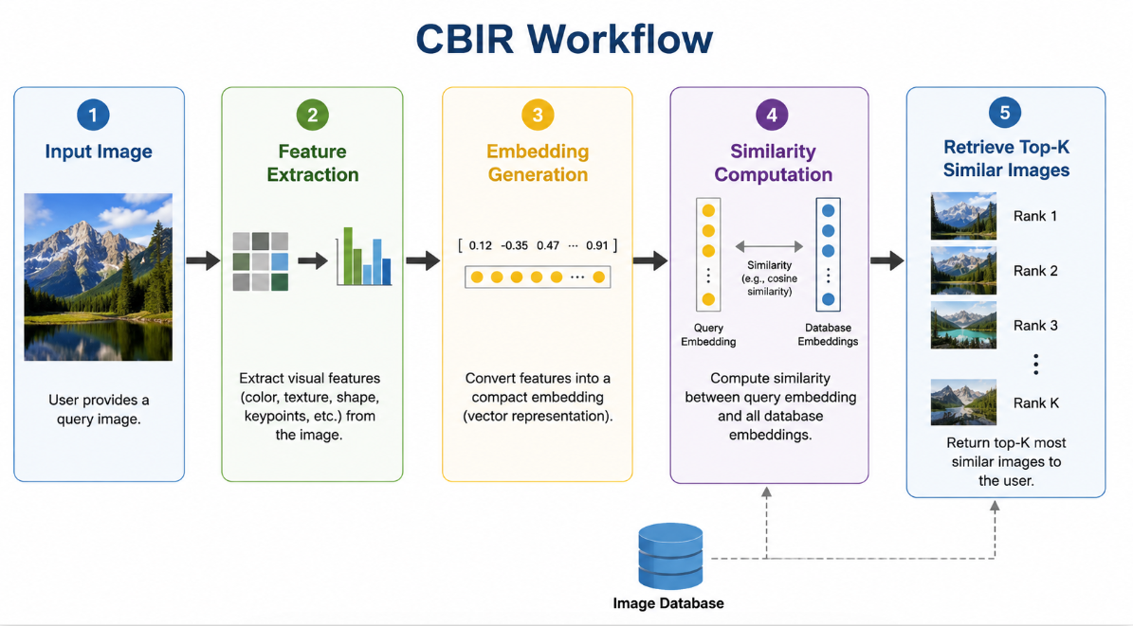
Figure 1 Content-Based Image Retrieval (CBIR)

2.6.1 Image Embeddings
Modern similarity retrieval systems do not compare images directly at the pixel level. Instead, each image is transformed into a compact numerical representation known as an embedding vector [17], [27].
An embedding is a high-dimensional feature vector that summarizes the essential visual characteristics of an image. Images with similar anatomical structures produce embeddings that are close together in the feature space, whereas unrelated images generate embeddings that are farther apart [17], [27].
Compared with raw pixel comparisons, embedding vectors offer several advantages [17], [27]:
- Robustness to illumination variations.
- Reduced sensitivity to image noise.
- Compact numerical representation.
- Faster similarity computation.
- Improved semantic understanding of image content.

2.6.2 Deep Feature Extraction Using ResNet18
Deep convolutional neural networks have demonstrated exceptional capability in learning discriminative image representations [6], [27]. Rather than training a feature extractor from scratch, many medical imaging applications employ transfer learning using networks pretrained on large-scale image datasets such as ImageNet [27], [28].
In the proposed BreastCare AI system, ResNet18 was selected as the feature extractor for similarity retrieval.
ResNet18 is a convolutional neural network consisting of 18 layers and introduces the concept of Residual Learning, where shortcut connections allow gradients to propagate efficiently through the network [27]. These residual connections alleviate the vanishing gradient problem and enable deeper architectures to learn more effectively [27].
The network architecture consists of:
- Initial convolution layer
- Batch normalization
- Residual blocks
- Global average pooling
- Fully connected classification layer
For embedding generation, the final fully connected classification layer is removed. The remaining convolutional layers act as a powerful feature extractor that converts each ultrasound image into a 512-dimensional feature vector [27], [28].
The advantages of using ResNet18 include [27], [28]:
- Lightweight architecture.
- Low memory requirements.
- Fast inference.
- Excellent transfer learning performance.
- Strong feature extraction capability.
These characteristics make ResNet18 particularly suitable for deployment within real-time medical web applications.

2.6.3 Feature Vector Representation
After preprocessing, every breast ultrasound image passes through the ResNet18 feature extractor [27]. Instead of predicting a diagnosis, the network produces a numerical vector that describes the visual appearance of the lesion [17], [27].
Each feature vector captures information regarding:
- Lesion shape.
- Texture.
- Edge characteristics.
- Internal echogenicity.
- Spatial intensity distribution.
These vectors become the foundation of the similarity retrieval system [17].
The generated embeddings are stored within the PostgreSQL database alongside image metadata, examination records, and diagnostic information. This allows efficient retrieval of historical examinations without repeatedly extracting features from every stored image [18], [31].

2.6.4 Cosine Similarity
After generating embedding vectors, a similarity metric is required to compare them [17], [18].
The proposed system employs Cosine Similarity, one of the most widely used similarity measures in computer vision and information retrieval [17], [18].
Rather than comparing vector magnitudes, cosine similarity measures the angle between two vectors [18].
The similarity between vectors A and B is defined as:
[
\text{Cosine Similarity}=\frac{A\cdot B}{|A||B|}
]
where:
- A · B represents the dot product of the vectors.
- |A| and |B| denote their Euclidean magnitudes.
Cosine similarity values range from:
- 1.0 → Identical images.
- 0.0 → Completely unrelated images.
- −1.0 → Opposite feature directions (rare in image embeddings).
Because feature vectors generated by deep neural networks primarily encode semantic information rather than absolute intensity values, cosine similarity has proven particularly effective for medical image retrieval [17], [18], [20].

2.6.5 Similarity Search Pipeline
The similarity retrieval component implemented in this project follows the pipeline illustrated below.
- Upload ultrasound image.
- Generate AI detection using YOLOv8.
- Extract deep features using ResNet18.
- Generate a 512-dimensional embedding vector.
- Retrieve all stored embeddings from PostgreSQL.
- Compute cosine similarity between the query embedding and each stored embedding.
- Rank images according to similarity score.
- Return the Top-5 most similar historical cases.
This workflow combines modern object detection with content-based image retrieval and enables clinicians to compare the current examination with previous cases that exhibit similar visual characteristics [15], [17], [18], [27].

2.6.6 Clinical Importance of Similarity Search
Similarity retrieval offers several advantages beyond conventional AI classification [17], [19].
First, it increases radiologists' confidence by presenting comparable historical examinations with known diagnoses [19], [20].
Second, it supports educational environments where junior physicians can study similar cases before making clinical decisions [19].
Third, retrieved images provide an additional layer of explainability. Rather than relying solely on a probability score, clinicians can visually inspect why the AI considers two lesions similar [17], [42].
Furthermore, similarity retrieval contributes to longitudinal patient monitoring. Future versions of the system may compare a patient's current examination with previous scans to identify subtle disease progression [17], [41].
For these reasons, combining YOLOv8 detection with deep embedding retrieval represents a significant enhancement over traditional computer-aided diagnosis systems [15], [17], [19].

2.6.7 Similarity Search in the Proposed BreastCare AI System
The BreastCare AI platform integrates similarity search directly into the diagnostic workflow.
After lesion detection, the uploaded ultrasound image is processed by the ResNet18 feature extractor. The resulting embedding is compared with embeddings generated from the BUSI dataset and stored within the PostgreSQL database [12], [27], [31].
The system retrieves the five most visually similar cases and displays them alongside:
- Similarity percentage.
- Image preview.
- Examination ID.
- Image ID.
This allows the radiologist to compare the current examination with historical cases before finalizing the medical report [17], [19].
Unlike many existing AI systems that provide only binary predictions, this integrated approach combines automated detection with clinically relevant case retrieval, improving interpretability and supporting evidence-based decision-making [15], [17], [42].

CHAPTER 3: SYSTEM ANALYSIS AND REQUIREMENTS

3.1 Existing System Analysis

Current breast cancer screening and diagnosis processes primarily rely on manual interpretation of mammogram images by radiologists. Although mammography remains the standard screening technique, the increasing number of examinations places significant pressure on healthcare professionals. Radiologists must carefully inspect each image for suspicious masses, calcifications, asymmetries, and architectural distortions.
Traditional systems suffer from several limitations:
• Dependence on radiologist expertise and experience.
• Long examination and reporting times.
• Possibility of human errors and missed abnormalities.
• Limited ability to compare current examinations with similar historical cases.
• Fragmented storage of patient records, images, and reports.
• Lack of integrated AI-assisted diagnostic support.
These limitations can affect diagnostic accuracy, workflow efficiency, and early breast cancer detection rates.

3.2 Proposed System
The proposed system, BreastCare AI, is an intelligent web-based platform that combines artificial intelligence, medical image processing, and healthcare information management into a unified solution.
The system enables hospitals and radiologists to:
• Upload mammogram images through a secure web interface.
• Automatically detect suspicious regions using a deep learning detection model.
• Classify mammograms into Normal, Benign, or Malignant categories.
• Generate probability scores and confidence values for predictions.
• Retrieve visually similar mammogram cases using image embedding similarity search.
• Store patient information, examinations, medical records, AI results, and diagnostic reports.
• Allow radiologists to review AI findings and create final medical reports.
• Enable administrators to monitor system activities, users, and audit logs.
The proposed solution aims to improve diagnostic support, reduce workload, and facilitate early breast cancer detection.

3.3 Functional Requirements

The system shall provide the following functional requirements:

User Management
• User registration and authentication.
• Login and logout functionality.
• Role-based access control.
• Password encryption and secure credential management.

Patient Management
• Create patient profiles.
• View and update patient information.
• Access patient medical history.

Hospital Management
• Register hospitals.
• Manage hospital accounts.
• Monitor examinations and reports.

Mammogram Management
• Upload mammogram images.
• Store image metadata.
• Associate images with patient examinations.

AI Analysis
• Detect suspicious breast lesions.
• Classify images into Normal, Benign, or Malignant categories.
• Calculate confidence and probability scores.
• Generate annotated images highlighting detected regions.

Similarity Search
• Generate image embeddings.
• Compare uploaded mammograms with stored datasets.
• Retrieve top similar mammogram cases.
• Display similarity percentages and historical examples.

Medical Reporting
• Generate AI analysis reports.
• Allow radiologists to write final diagnostic reports.
• Save physician recommendations.
• Download reports as PDF documents.

Administration
• View system logs.
• Monitor user activities.
• Manage users and permissions.
• Audit database and system operations.

3.4 Non-Functional Requirements
The system shall satisfy the following non-functional requirements:

Performance
• AI analysis should be completed within a reasonable response time.
• Similarity search should return results efficiently.
• Database queries should be optimized for large datasets.

Reliability
• Ensure stable operation during image processing.
• Prevent data loss through backup mechanisms.
• Handle unexpected failures gracefully.

Security
• Encrypt user passwords.
• Implement authentication and authorization.
• Protect sensitive patient information.
• Maintain audit logs for accountability.

Scalability
• Support increasing numbers of users and examinations.
• Handle growing medical image datasets.
• Allow future integration of additional AI models.

Usability
• Provide a user-friendly interface.
• Minimize training requirements for healthcare staff.
• Ensure easy navigation and accessibility.

Maintainability
• Modular system architecture.
• Easy deployment and updates.
• Clear separation between frontend, backend, database, and AI services.

3.5 User Roles and Permissions

The system contains three primary user roles:

Patient
Patients can:
• Access their personal profile.
• View examination history.
• View AI-generated reports.
• Review physician recommendations.
Patients cannot:
• Upload medical images.
• Modify medical reports.
• Access other patients' information.

Hospital / Radiologist
Hospitals and radiologists can:
• Register and manage patients.
• Upload mammogram images.
• Request AI analysis.
• Review AI findings.
• Create and edit final medical reports.
• Access similarity search results.
• Manage examinations and medical records.

Administrator
Administrators can:
• Manage all user accounts.
• View system logs.
• Monitor platform activity.
• Manage hospitals and radiologists.
• Review AI-generated reports.
• Configure system settings.
• Audit security and database operations.
Administrators have the highest level of system access.

3.6 Use Case Analysis
The major use cases of the BreastCare AI system include:
Use Case 1: User Login
Actor: Patient, Hospital, Administrator
Description:
- User enters credentials.
- System verifies credentials.
- User is authenticated.
- Appropriate dashboard is displayed.
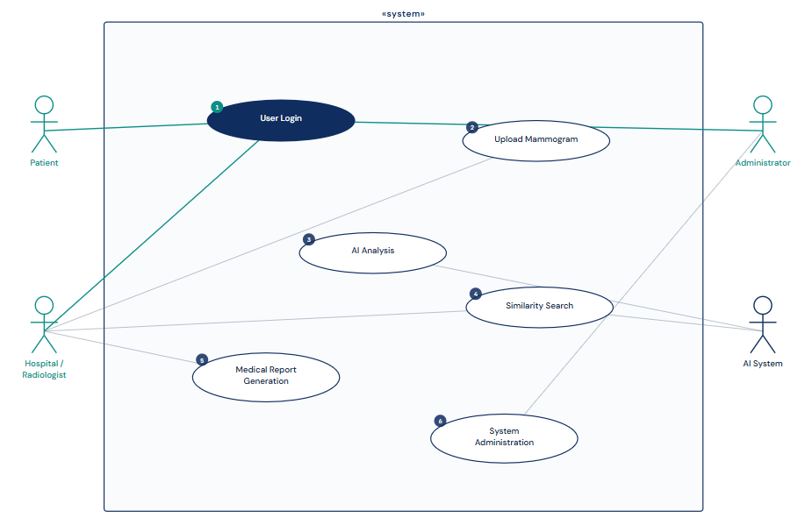
Figure 2 Use Case 1: User Login

Use Case 2: Upload Mammogram
Actor: Hospital/Radiologist
Description:
- User selects a patient examination.
- Mammogram image is uploaded.
- Image is stored in the database.
- AI analysis is triggered.
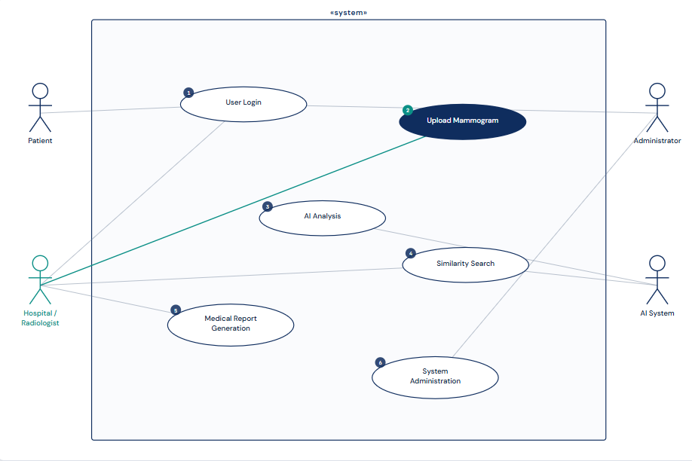
Figure 3 Use Case 2: Upload Mammogram

Use Case 3: AI Analysis
Actor: AI System
Description:
- Uploaded image is processed.
- Detection model identifies suspicious regions.
- Classification model predicts image category.
- Confidence scores are generated.
- Results are stored in the database.
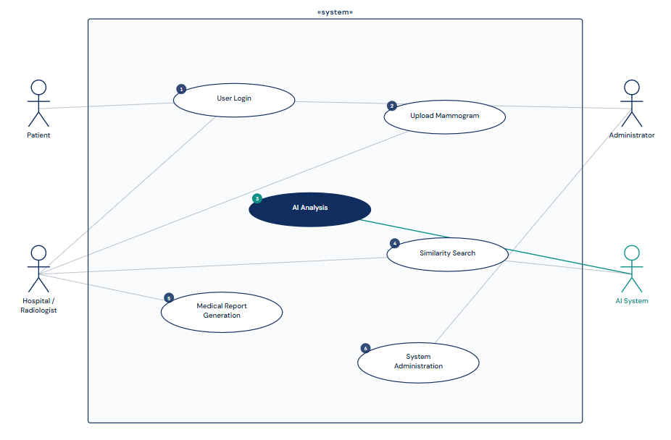
Figure 4 Use Case 3: AI Analysis

Use Case 4: Similarity Search
Actor: Hospital/Radiologist
Description:
- AI generates image embeddings.
- Similarity engine compares embeddings.
- Most similar mammograms are retrieved.
- Similar cases are displayed to the user.
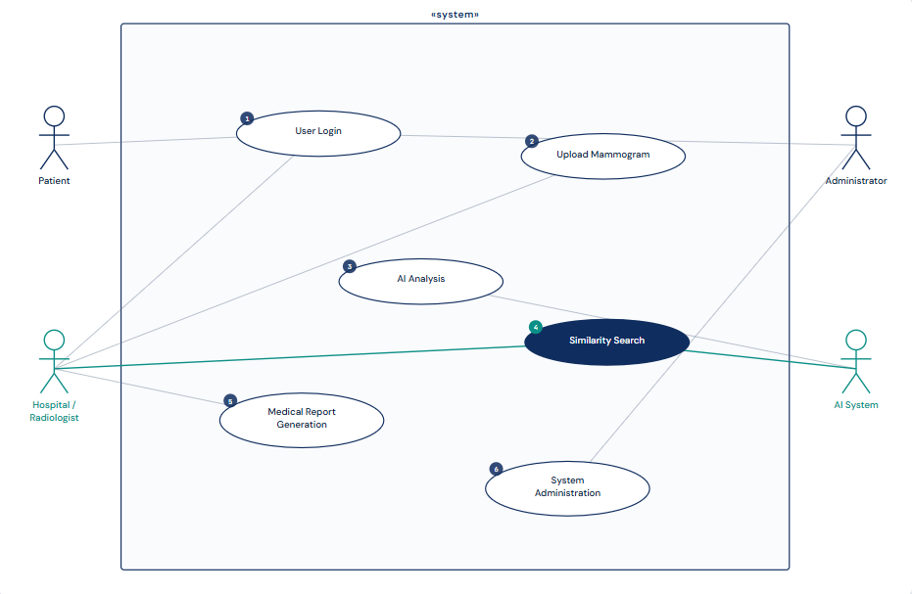
Figure 5 Use Case 4: Similarity Search

Use Case 5: Medical Report Generation
Actor: Hospital/Radiologist
Description:
- AI findings are reviewed.
- Radiologist writes diagnostic interpretation.
- Final report is saved.
- PDF report can be generated and downloaded.
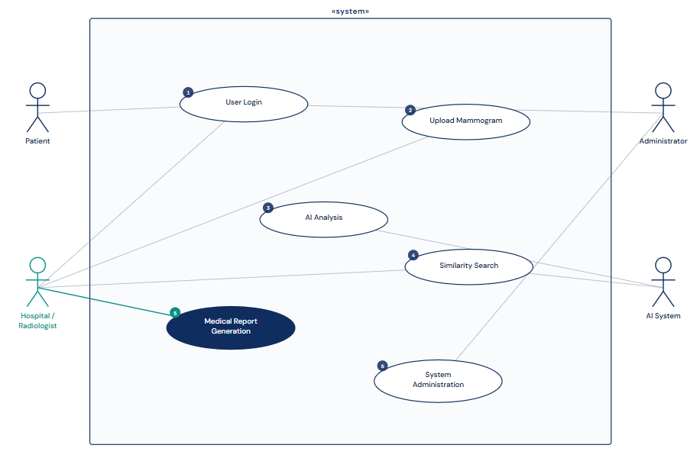
Figure 6 Use Case 5: Medical Report Generation

Use Case 6: System Administration
Actor: Administrator
Description:
- Administrator accesses the admin dashboard.
- Reviews logs and user activities.
- Manages user accounts.
- Monitors system performance and security events.
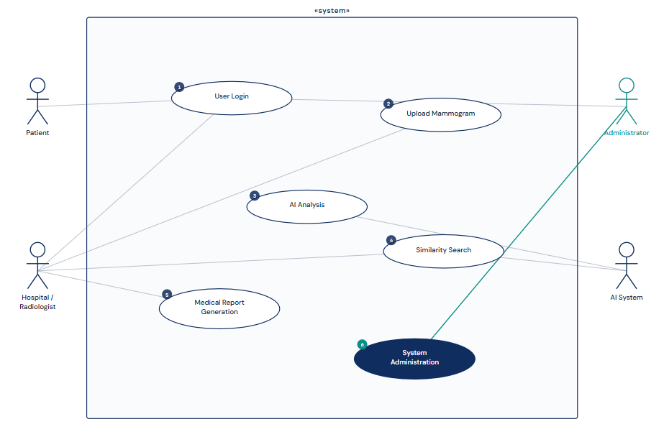
Figure 7 Use Case 6: System Administration

CHAPTER 4: SYSTEM DESIGN

4.1 Overall System Architecture
The BreastCare AI system follows a multi-tier architecture consisting of a frontend layer, backend layer, database layer, and artificial intelligence layer. The architecture is designed to ensure scalability, maintainability, security, and efficient processing of medical images.
The frontend layer provides the user interface through which patients, hospitals, radiologists, and administrators interact with the system. The frontend is implemented using React and communicates with the backend through RESTful APIs.
The backend layer is implemented using FastAPI and acts as the central controller of the system. It handles user authentication, image uploads, database operations, report generation, similarity search requests, and communication with AI services.
The database layer utilizes PostgreSQL to store patient information, hospitals, radiologists, mammogram images, examinations, AI reports, embeddings, audit logs, and administrative data.
The artificial intelligence layer contains the trained YOLO-based breast cancer classification model and the embedding generation service used for similarity search. Uploaded images are processed by the AI model to generate predictions, confidence scores, annotated images, and image embeddings.

4.2 Database Design
The database was designed using a relational approach to ensure data consistency, integrity, and efficient querying.
The system stores:
- User accounts
- Patient records
- Hospital records
- Radiologist information
- Examinations
- Mammogram images
- AI reports
- Similarity embeddings
- Medical procedures
- System logs
The design follows normalization principles to reduce redundancy and maintain data integrity.

Main Database Tables
Table 5 Main Database Tables
Table | Purpose
Users | Authentication and authorization
Patient | Patient information
Hospital | Hospital information
Radiologist | Radiologist information
Visit | Visit information
Exam | Mammogram examinations
Mammogram Images | Uploaded images
AI Report | AI-generated results
Mammogram Embeddings | Similarity search vectors
Procedure | Medical procedures
Logs | Audit trails

4.3 Entity Relationship Diagram (ERD)
he ERD illustrates the relationships between all entities in the BreastCare AI database.

Main Relationships
- One Hospital employs many Radiologists.
- One Patient can have many Examinations.
- One patient may have multiple visits.
- One Radiologist can review many Examinations.
- One visit may include multiple medical procedures.
- One visit may generate multiple examinations.
- One Examination can contain many Mammogram Images.
- One Examination generates one AI Report.
- One Mammogram Image has one Embedding.
- One User account belongs to one Patient, Hospital, or Administrator.
- Logs record actions performed by users.
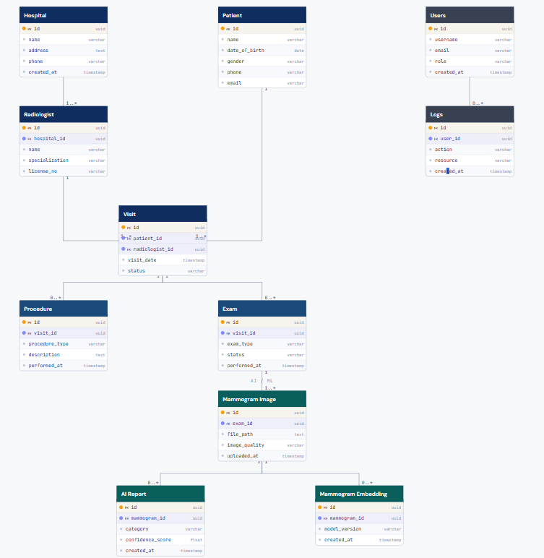
Figure 8 Entity Relationship Diagram (ERD)

4.4 Data Flow Diagram (DFD)

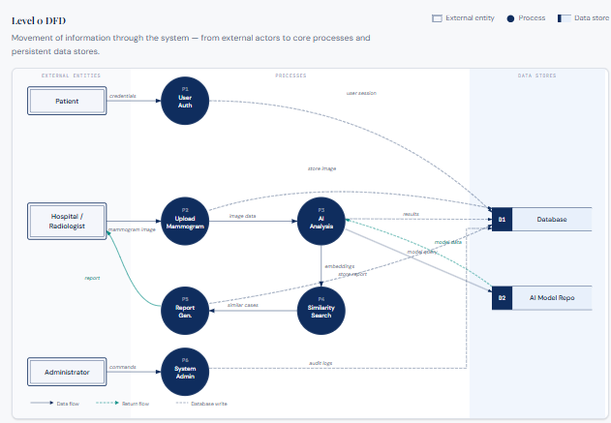
Figure 9 Data Flow Diagram (DFD)

4.5 System Flowcharts

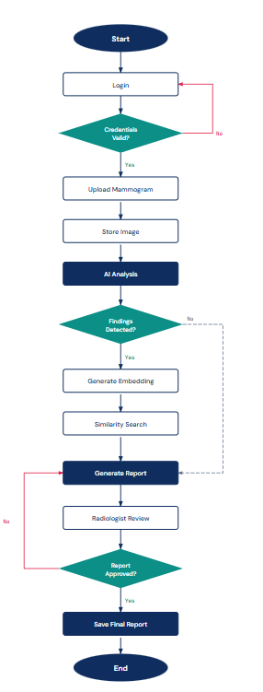
Figure 10 System Flowcharts

4.6 User Interface Design
The user interface was designed to be simple, responsive, and user-friendly.

Main Screens

Home Page
Provides project information and access to login and registration.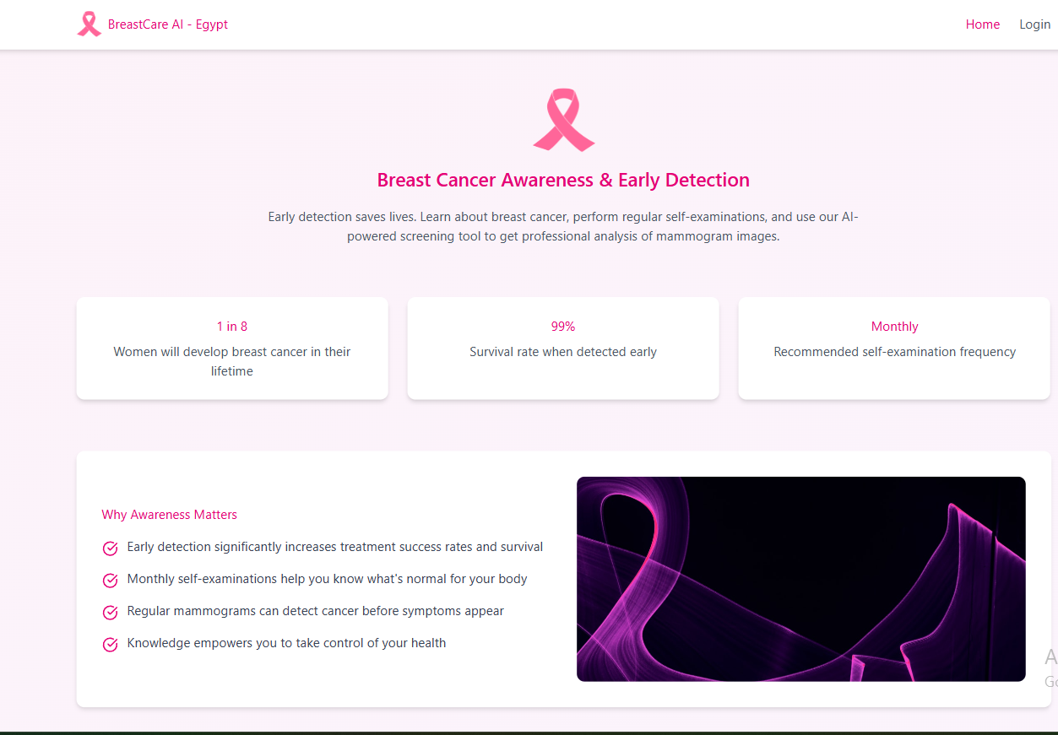
Figure 11 Home Page UI

Login and Registration
Allows secure authentication for patients, hospitals, and administrators.
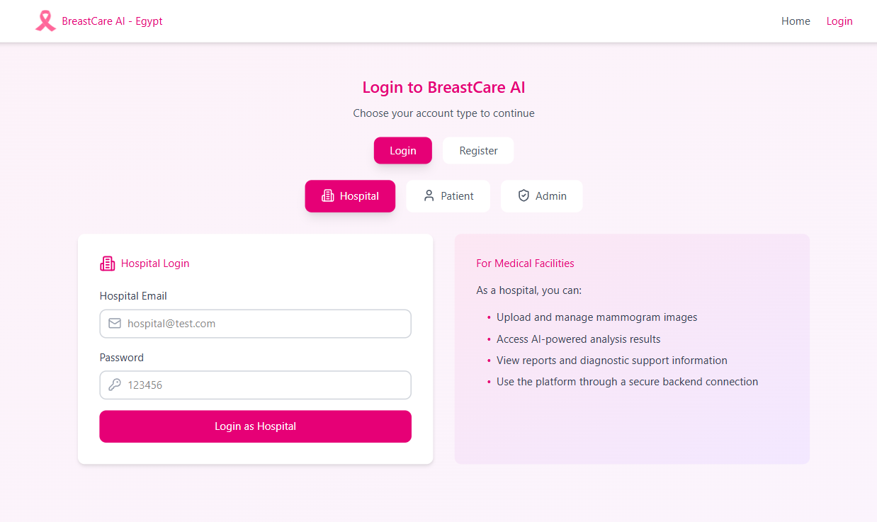
Figure 12 Login and Registration UI

Hospital Dashboard
Allows:
- Patient management
- Examination management
- Image upload
- AI report review
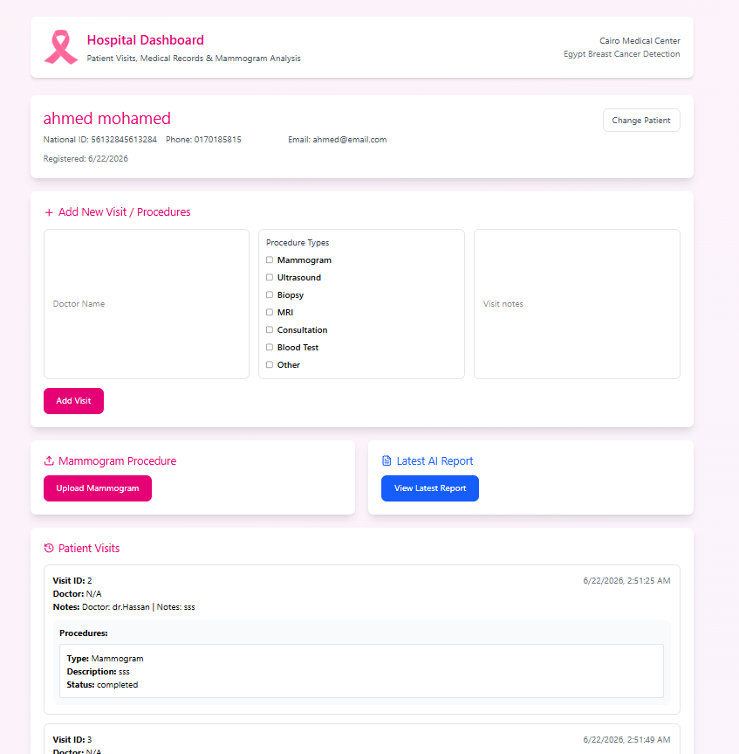
Figure 13 Hospital Dashboard UI

Patient Dashboard
Allows:
- Viewing examination history
- Viewing reports
- Downloading reports
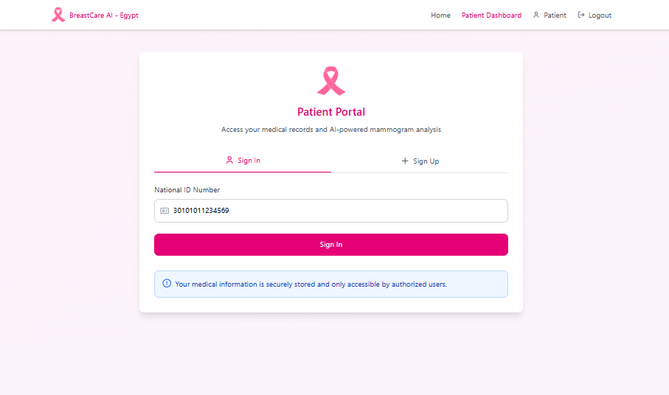
Figure 14 Patient Dashboard

Upload Page
Allows:
- Mammogram image upload
- Exam selection
- AI analysis initiation
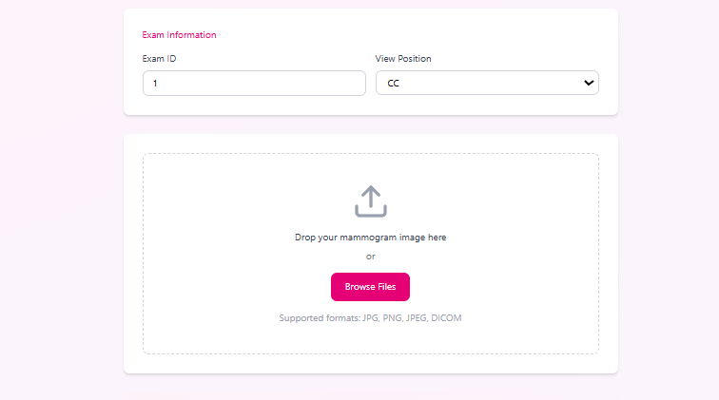
Figure 15 Upload Page UI
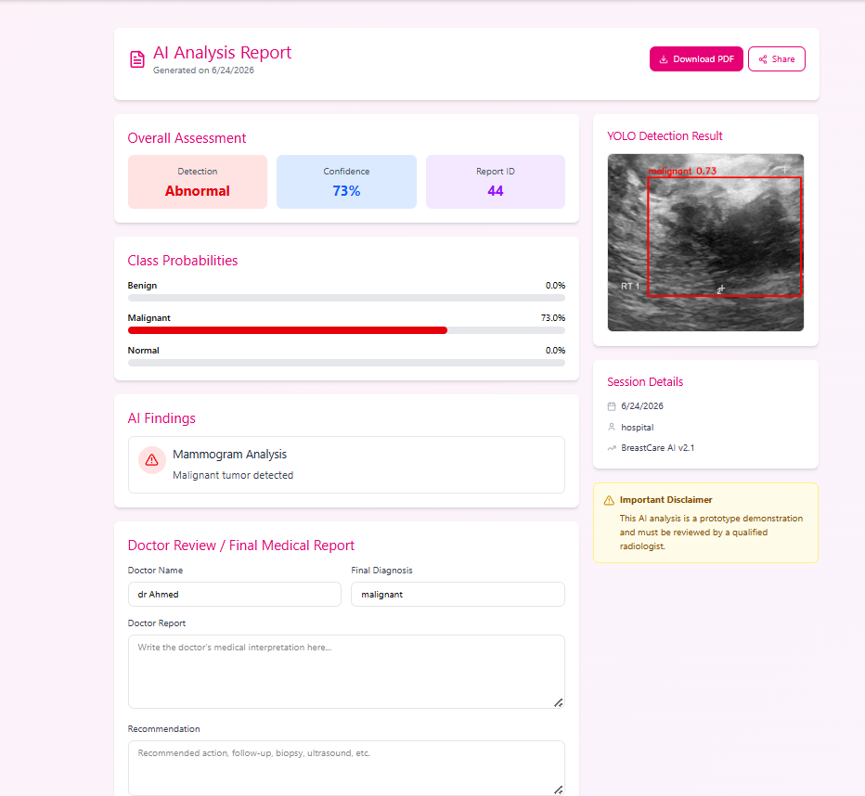
Figure 16 AI Analysis Report UI

Report Page
Displays:
- AI prediction
- Confidence score
- Annotated image
- Similar cases
- Doctor report
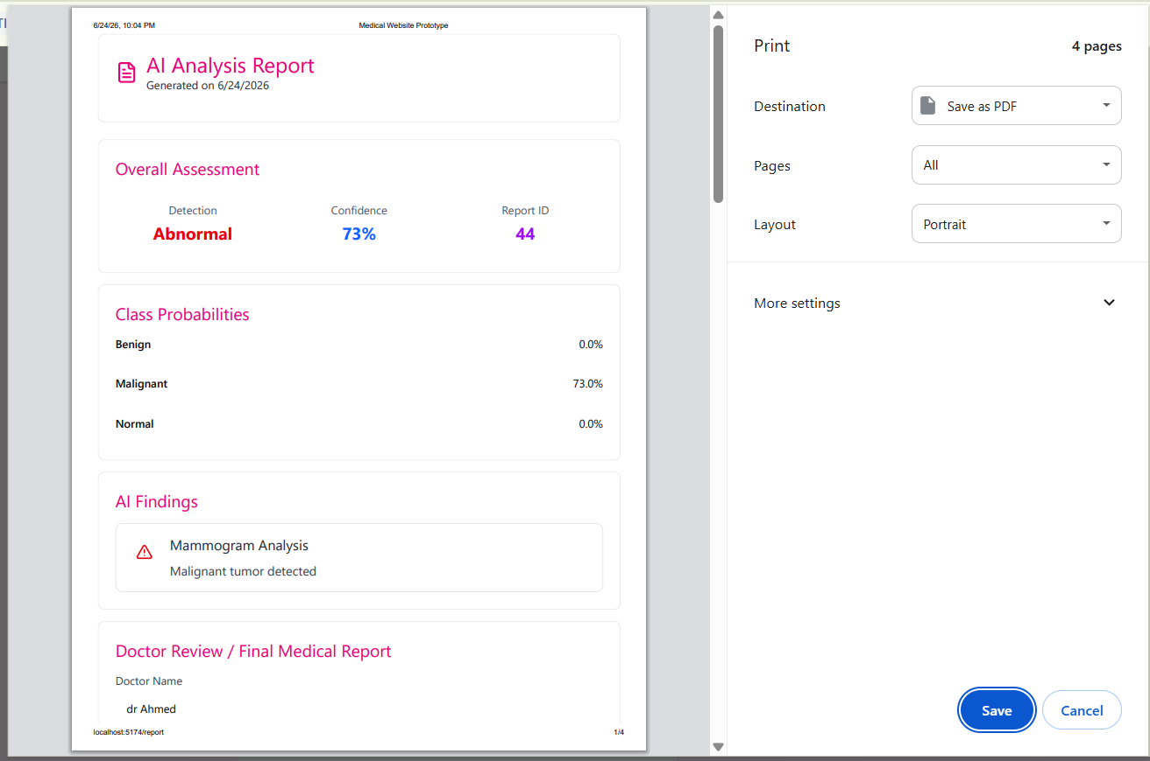
Figure 17 Report Page UI

Admin Dashboard
Allows:
- User management
- Log monitoring
- System oversight
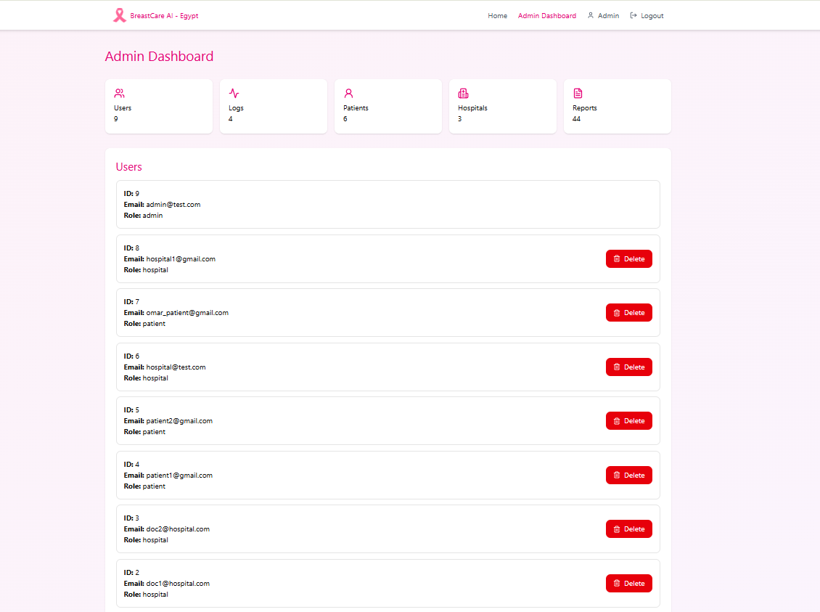
Figure 18 Admin Dashboard UI

4.7 Security Design
Since the system handles sensitive medical information, several security mechanisms were implemented.

Authentication
- JWT token-based authentication.
- Secure login and logout.
- Session validation.

Authorization
Role-based access control:
- Patient
- Hospital/Radiologist
- Administrator
Each role can access only authorized resources.

Data Protection
- Password hashing.
- Secure API communication.
- Protected medical records.
- Audit logging.

Audit Trail
All important actions are recorded:
- Login attempts
- Image uploads
- AI analyses
- Report generation
- Administrative actions

CHAPTER 5: IMPLEMENTATION AND METHODOLOGY

5.1 Development Environment
The BreastCare AI system was developed using a modern full-stack architecture consisting of frontend, backend, database, and artificial intelligence components.

Hardware Environment
The development and testing environment consisted of:
• Intel-based personal computer
• 16 GB RAM
• SSD Storage
• Windows 10/11 Operating System

Software Environment
The following technologies were used:
Table 6 Software Environment
Component | Technology
Frontend | React + TypeScript
Backend | FastAPI
Database | PostgreSQL
ORM | SQLAlchemy
Authentication | JWT
AI Framework | PyTorch
Detection Model | YOLO
Similarity Search | Embedding-Based Retrieval
Version Control | Git & GitHub
Development Tools | VS Code
The development process followed a modular architecture separating frontend, backend, AI services, and database operations

5.2 Frontend Implementation (React)
The frontend was developed using React and TypeScript to provide a responsive and interactive user interface.

Main Components
The frontend consists of several pages:
• Home Page
• Login Page
• Patient Dashboard
• Hospital Dashboard
• Upload Mammogram Page
• AI Report Page
• Admin Dashboard

React Features Used
• React Router for navigation
• Functional Components
• React Hooks
• Axios API communication
• State Management using useState
• Responsive layouts using Tailwind CSS

Frontend Workflow
- User logs in.
- Authentication token is stored.
- User accesses dashboard.
- Mammogram images are uploaded.
- Results are fetched from backend APIs.
- Reports and similarity results are displayed

5.3 Backend Implementation (FastAPI)
The backend was implemented using FastAPI due to its high performance and automatic API documentation.

Backend Responsibilities
• Authentication
• User Management
• Patient Management
• Hospital Management
• Image Upload
• AI Analysis
• Similarity Search
• Report Generation
• Administrative Operations

API Structure
The backend is divided into route modules:
• auth.py
• patients.py
• hospitals.py
• exams.py
• uploads.py
• ai_reports.py
• similarity.py
• admin.py
• logs.py

API Communication
The frontend communicates with the backend through RESTful APIs using JSON requests and responses.

5.4 Database Implementation (PostgreSQL)
PostgreSQL was selected as the primary database because of its reliability, security, and scalability.

Database Tables
The implemented database contains:
• Users
• Patients
• Hospitals
• Radiologists
• Visits
• Procedures
• Exams
• Mammogram Images
• AI Reports
• Mammogram Embeddings
• Logs

Database Features
• Foreign Key Constraints
• Transaction Management
• Data Integrity Enforcement
• Indexed Queries
• Relationship Mapping using SQLAlchemy
The database serves as the central repository for all patient, image, AI, and administrative data.

5.5 Authentication and Authorization
Authentication was implemented using JSON Web Tokens (JWT).

Login Process
- User submits credentials.
- Credentials are verified.
- Password hash is compared.
- JWT token is generated.
- Token is returned to the frontend.

User Roles
The system supports:
• Patient
• Hospital/Radiologist
• Administrator

Authorization
Role-based access control (RBAC) restricts access to resources according to user permissions.

Security Measures
• Password Hashing
• JWT Tokens
• Protected API Routes
• Session Validation

5.6 AI Detection Model
The artificial intelligence module performs automatic breast lesion detection and classification.

Dataset
The model was trained using the Breast Ultrasound Images Dataset (BUSI), which contains:
• Benign Cases
• Malignant Cases
• Normal Cases

Model Architecture
The project utilizes a YOLO-based model for breast lesion detection and classification.
The model predicts:
• Lesion Location
• Class Label
• Confidence Score

Output Classes
• Benign
• Malignant
• Normal

AI Pipeline
- Image Upload
- Image Preprocessing
- Model Inference
- Prediction Generation
- Confidence Calculation
- Result Storage
The generated results are stored in the AI Report table.

5.7 Similarity Search System
The similarity search module retrieves mammograms that visually resemble the uploaded image.

Process
- Generate query image embedding.
- Retrieve stored embeddings.
- Calculate similarity scores.
- Rank results.
- Return Top 5 Similar Mammograms.

Similarity Metric
Cosine Similarity is used to compare feature vectors.

Output
The system displays:
• Similar Images
• Similarity Percentage
• Image ID
• Exam ID
This functionality assists radiologists by providing reference cases.

5.8 Medical Report Generation
fter AI analysis, radiologists can review the findings and generate a final diagnostic report.

Report Components
• AI Prediction
• Confidence Score
• Similar Cases
• Doctor Name
• Final Diagnosis
• Clinical Notes
• Recommendations

Workflow
- AI analysis completed.
- Results displayed.
- Doctor reviews findings.
- Medical report is written.
- Report is saved.
- PDF report is generated for download.
The report combines AI assistance with expert medical judgment.

5.9 Administration and Audit Logging
The administration module allows system monitoring and auditing.

Administrative Functions
• User Management
• Log Monitoring
• AI Report Review
• Hospital Monitoring

Audit Logs
The system records:
• Login Events
• Upload Operations
• AI Analysis Requests
• Report Generation
• Administrative Actions

Logged Information
• User ID
• Timestamp
• Action Type
• IP Address
• Details
Audit logging improves accountability and system security.

5.10 Version Control and Collaboration
Version control was managed using Git and GitHub.

Git Workflow
- Local Development
- Commit Changes
- Push to GitHub Repository
- Review Updates
- Deploy New Versions

Benefits
• Code Backup
• Collaboration
• Change Tracking
• Version History
• Branch Management
GitHub served as the central repository for source code, documentation, and project management throughout the development lifecycle.

CHAPTER 6: TESTING AND EVALUATION

6.1 Dataset Description
The performance of any deep learning model is highly dependent on the quality, diversity, and size of the dataset used during training and evaluation. In medical image analysis, selecting an appropriate dataset is particularly important because the model must learn subtle visual patterns associated with different pathological conditions while maintaining the ability to generalize to unseen clinical cases. Several publicly available breast imaging datasets have been introduced to facilitate the development and benchmarking of artificial intelligence algorithms for breast cancer diagnosis. Among these, the Curated Breast Imaging Subset of the Digital Database for Screening Mammography (CBIS-DDSM), the Breast Ultrasound Images (BUSI) dataset, and YOLO-formatted breast ultrasound datasets available through Kaggle are the most widely used [33]–[35].
The CBIS-DDSM dataset is a curated version of the Digital Database for Screening Mammography and contains digitized mammographic examinations acquired from approximately 1,555 patients, comprising 2,907 mammography images. The dataset includes both benign and malignant breast lesions with detailed annotations for masses and calcifications. Due to its high image resolution, typically around 3000 × 4800 pixels, CBIS-DDSM provides rich anatomical information suitable for lesion detection, segmentation, and classification. However, its large image size significantly increases computational requirements and often necessitates image resizing before model training, which may result in the loss of fine diagnostic details [33]. The analysis presented in the project report also highlighted that the high resolution of CBIS-DDSM can lead to increased training time and greater GPU memory consumption.
To address these limitations, this project also considered the Breast Ultrasound Images (BUSI) dataset, which has become one of the most commonly used benchmark datasets for breast ultrasound analysis. The BUSI dataset was collected at Baheya Hospital in Cairo, Egypt, and contains ultrasound images acquired from 600 female patients. The dataset consists of a total of 780 images divided into three clinically significant categories: 437 benign lesions, 210 malignant lesions, and 133 normal examinations. In addition to the ultrasound images, BUSI provides corresponding binary segmentation masks for lesion localization, making it suitable for object detection, segmentation, and classification research [34]. Compared with mammography datasets, BUSI images have a considerably smaller spatial resolution, approximately 500 × 500 pixels, which reduces computational complexity while preserving sufficient diagnostic information for deep learning applications.
The project also evaluated a YOLO-formatted breast ultrasound dataset obtained from Kaggle, specifically designed for object detection tasks. Unlike the BUSI dataset, which requires preprocessing and annotation conversion before training object detection models, the Kaggle dataset is already organized according to the YOLO annotation format. This considerably simplifies the training pipeline by allowing direct use with the Ultralytics YOLO framework. Furthermore, the dataset contains well-defined bounding box annotations that improve localization performance during model training. Experimental observations summarized in the project report demonstrated that this dataset provided superior detection accuracy and smoother integration with the YOLOv8 training framework compared with manually converted datasets [35].
Following a comparative evaluation of these datasets, a hybrid strategy was adopted for the proposed BreastCare AI system. The YOLO-formatted Kaggle dataset was selected for training the object detection model because of its high-quality annotations and compatibility with the Ultralytics implementation, whereas the BUSI dataset was selected for building the similarity search database. The BUSI images were imported into the PostgreSQL database, where a deep embedding was generated for every ultrasound image using a pretrained ResNet18 feature extractor. These embeddings enable efficient content-based image retrieval and support the similarity search functionality implemented within the system.
Table 6.1 summarizes the characteristics of the three datasets considered during this project.
Table 7 Comparison of Breast Imaging Datasets Used in This Study

Comparison of Breast Imaging Datasets Used in This Study
Dataset | Imaging Modality | Number of Images | Classes | Primary Usage
CBIS-DDSM | Mammography | 2,907 | Benign, Malignant | Detection, Segmentation
BUSI | Ultrasound | 780 | Normal, Benign, Malignant | Similarity Search, Classification
Kaggle YOLO Breast Ultrasound | Ultrasound | YOLO-formatted | Benign, Malignant | YOLOv8 Detection Training
Each dataset contributed differently to the proposed system. CBIS-DDSM served as a reference for evaluating mammography-based research, BUSI was employed to construct the similarity search repository, and the Kaggle YOLO dataset was used to train the final object detection model integrated into the BreastCare AI platform. This combination allowed the system to exploit the strengths of each dataset while mitigating their individual limitations, resulting in a more comprehensive breast cancer diagnosis framework.

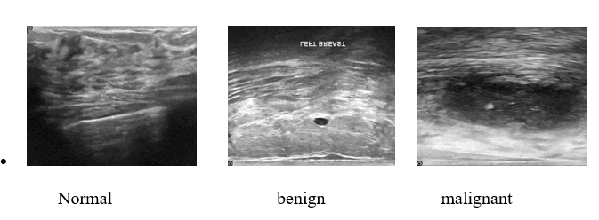
Figure 19 Sample images from the BUSI dataset (Normal, Benign, and Malignant).
.
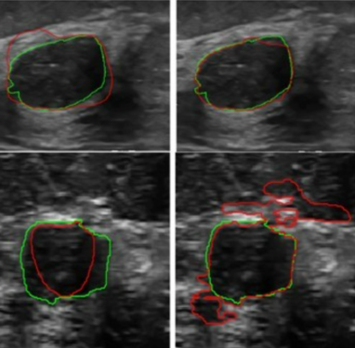
Figure 20 Example images from the Kaggle YOLO breast ultrasound dataset with bounding box annotations

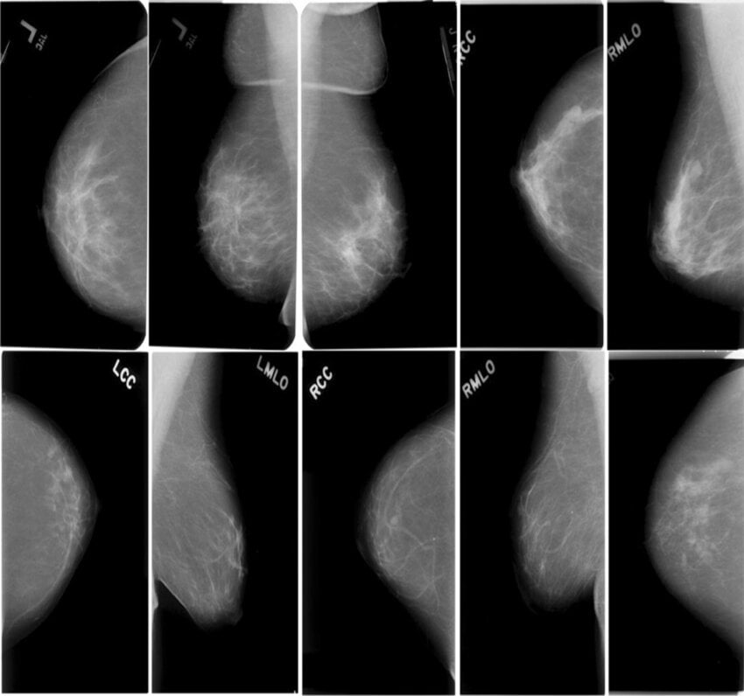
Figure 21 • Example mammograms from the CBIS-DDSM dataset.

6.2 Data Preprocessing
Data preprocessing is a critical stage in the development of deep learning models because the quality of the input data directly influences the model's learning capability and generalization performance. Medical images often contain variations in resolution, brightness, contrast, noise, and imaging artifacts due to differences in acquisition devices and scanning protocols. Therefore, preprocessing techniques are applied to standardize the input images before they are presented to the deep learning model [36].
In this project, preprocessing was performed separately for the object detection model and the similarity search module. Although both components operate on breast ultrasound images, each requires different image representations depending on its specific task.

6.2.1 Dataset Organization
Before training the detection model, the breast ultrasound images were organized into a directory structure compatible with the Ultralytics YOLO framework. Images and their corresponding annotation files were separated into training, validation, and testing subsets. Each annotation file contained the normalized coordinates of the lesion bounding box together with its associated class label, allowing YOLOv8 to learn both lesion localization and classification simultaneously [15].
The three diagnostic categories used throughout this project were:
- Benign
- Malignant
- Normal
This organization ensured consistency between the training dataset and the output classes generated by the deployed AI model.

6.2.2 Image Resizing
Deep learning models require fixed-size inputs. Consequently, all ultrasound images were resized before training and inference. During YOLOv8 training, each image was automatically resized to the input dimensions specified by the Ultralytics framework while preserving the lesion characteristics required for accurate detection [15].
Image resizing offers several advantages:
- Standardizes input dimensions.
- Reduces computational complexity.
- Accelerates training.
- Enables batch processing.
- Reduces GPU memory consumption.
Although resizing may remove a small amount of fine image detail, the selected input resolution preserved sufficient diagnostic information for lesion localization.

6.2.3 Image Normalization
Following resizing, image intensities were normalized before being processed by the neural network. Normalization scales pixel values into a consistent numerical range, preventing large intensity differences from dominating the optimization process [16].
For the embedding generation module, grayscale ultrasound images were converted into three-channel images before being passed to the pretrained ResNet18 feature extractor. The images were subsequently normalized using the ImageNet mean and standard deviation values employed during the original ResNet18 training process [27].
This preprocessing step ensured compatibility between the ultrasound images and the pretrained convolutional neural network used for feature extraction.

6.2.4 Data Annotation
Accurate annotation is essential for supervised object detection. Each training image was associated with a YOLO annotation file describing the location and class of every visible lesion.
The annotation format consisted of:
- Class identifier.
- Normalized center coordinates.
- Normalized bounding box width.
- Normalized bounding box height.
Compared with pixel-based annotations, the YOLO format provides a compact representation while maintaining accurate localization information. This format also allows direct compatibility with the Ultralytics training framework without requiring additional annotation conversion [15].

6.2.5 Feature Extraction Preprocessing
The similarity search subsystem required a different preprocessing pipeline from the detection model because its objective was to generate robust image embeddings rather than detect lesions.
Each ultrasound image underwent the following preprocessing sequence before feature extraction:
- Image loading.
- Conversion to grayscale.
- Resizing to 224 × 224 pixels.
- Conversion into a three-channel image.
- Tensor transformation.
- Pixel normalization.
- Feature extraction using ResNet18.
The final fully connected classification layer of ResNet18 was removed so that the network produced a high-dimensional feature vector instead of a diagnostic prediction. This feature vector served as the image embedding stored within the PostgreSQL database for similarity retrieval [27].

6.2.6 Embedding Database Preparation
To enable content-based image retrieval, every BUSI image imported into the system was processed by the embedding generation module.
For each image, the following operations were performed:
- Feature extraction using ResNet18.
- Generation of a 512-dimensional embedding vector.
- Storage of the embedding in PostgreSQL.
- Association of the embedding with the corresponding mammogram image record.
Unlike traditional retrieval systems that compare raw pixel values, the proposed system compares semantic image representations, enabling more meaningful retrieval of visually similar breast lesions [17].

6.2.7 Preprocessing Workflow
The complete preprocessing workflow implemented in the proposed BreastCare AI system is illustrated in Figure 6.4.
The workflow consists of the following stages:
- Breast ultrasound image acquisition.
- Dataset validation.
- Image resizing.
- Image normalization.
- Dataset annotation.
- YOLOv8 training.
- ResNet18 feature extraction.
- Embedding generation.
- PostgreSQL storage.
- AI inference and similarity retrieval.
This preprocessing pipeline ensures that both the detection model and the similarity search system receive standardized, high-quality input data while minimizing computational overhead and maximizing diagnostic performance.

6.3 Model Training
The effectiveness of a deep learning model depends not only on the quality of the dataset but also on the training methodology, hyperparameter selection, and optimization strategy. In this project, the breast lesion detection model was developed using the Ultralytics YOLOv8 framework, which provides a robust and efficient implementation for real-time object detection [15]. YOLOv8 was selected because of its improved detection accuracy, simplified training pipeline, and excellent balance between computational efficiency and inference speed.
Unlike traditional object detection approaches that require separate stages for region proposal and classification, YOLOv8 performs lesion localization and classification simultaneously within a single forward pass. This one-stage architecture significantly reduces computational cost while maintaining high detection performance, making it suitable for real-time medical imaging applications [14], [15].

6.3.1 Training Environment
The training process was conducted using the Ultralytics implementation of YOLOv8 within the Python ecosystem. The framework provides automated data loading, augmentation, optimization, validation, and model checkpointing, allowing efficient experimentation with different datasets and hyperparameter configurations [15].
The software environment consisted of:
- Python 3.x
- Ultralytics YOLOv8
- PyTorch
- CUDA-enabled GPU (when available)
- OpenCV
- NumPy
The experiments were developed using Visual Studio Code as the primary development environment. PostgreSQL was employed to store the final AI predictions and metadata generated by the trained model, while FastAPI provided the inference interface integrated into the BreastCare AI web application.

6.3.2 Dataset Preparation
Before training, the selected ultrasound dataset was converted into the standard YOLO directory structure consisting of images and corresponding annotation files. Each annotation file contained the normalized coordinates of the lesion together with its class identifier.
The dataset was divided into three subsets:
- Training set
- Validation set
- Testing set
The validation subset was used during training to monitor the learning process and prevent overfitting, whereas the testing subset was reserved for evaluating the final model after training completion [15].
The three diagnostic classes included:
- Benign
- Malignant
- Normal
This organization enabled the model to learn lesion localization while simultaneously distinguishing between different pathological conditions.

6.3.3 Hyperparameter Configuration
Model performance is highly influenced by the selection of training hyperparameters. During training, several parameters were configured according to the recommendations of the Ultralytics framework and the experimental observations reported in the project study.
Table 6.3 summarizes the principal training configuration.

Table 8 YOLOv8 Training Configuration
Parameter | Value
Model | YOLOv8
Framework | Ultralytics
Input Image Size | 640 × 640
Optimizer | Default Ultralytics Optimizer
Loss Function | YOLO Detection Loss
Classes | 3
Dataset | Kaggle Breast Ultrasound Dataset
Transfer Learning | Enabled
Best Model | best.pt
The model was initialized using pretrained weights, allowing transfer learning from large-scale natural image datasets before fine-tuning on breast ultrasound images. Transfer learning substantially reduces training time while improving convergence and generalization, particularly when relatively small medical datasets are available [27].

6.3.4 Optimization Strategy
The optimization process consisted of repeatedly presenting batches of annotated ultrasound images to the neural network. During each iteration, the model predicted bounding box locations, object confidence scores, and lesion classes. These predictions were compared with the ground truth annotations using the YOLO detection loss function, which combines localization loss, classification loss, and objectness loss [15].
Model parameters were updated using gradient-based optimization until convergence was achieved.
The overall training procedure followed these steps:
- Load training images.
- Apply automatic preprocessing and augmentation.
- Perform forward propagation.
- Compute detection loss.
- Perform backpropagation.
- Update network weights.
- Evaluate performance on the validation dataset.
- Save the best-performing model.
Rather than selecting the final epoch, the Ultralytics framework automatically stores the model that achieves the highest validation performance as best.pt, which was subsequently integrated into the FastAPI backend for deployment.

6.3.5 Training Monitoring
Throughout the training process, several performance indicators were continuously monitored to evaluate learning progress and detect potential overfitting. These indicators included:
- Training loss
- Validation loss
- Precision
- Recall
- Mean Average Precision (mAP@0.5)
- Mean Average Precision (mAP@0.5:0.95)
Monitoring these metrics allowed the researchers to determine whether the model continued improving or had reached convergence. The project report indicates that repeated experimentation and dataset comparison were performed before selecting the final YOLOv8 model integrated into the BreastCare AI system.

6.3.6 Selection of the Final Model
Several publicly available breast ultrasound datasets were investigated during the experimental phase. After comparative evaluation, the YOLO-formatted Kaggle dataset demonstrated superior compatibility with the Ultralytics framework and produced better lesion localization performance than manually converted datasets. Consequently, the model trained using this dataset was selected as the final detection model for deployment within the proposed system.
The selected model was exported as best.pt and incorporated into the FastAPI backend. During system operation, every uploaded ultrasound image is processed by this model to generate:
- Lesion bounding boxes.
- Predicted diagnostic class.
- Confidence score.
- Class probability distribution.
- Annotated output image.
The generated results are stored within the PostgreSQL database and subsequently displayed through the React frontend.

6.3.7 Integration with the Proposed System
One of the main contributions of this project is the seamless integration of the trained YOLOv8 model into a complete web-based clinical workflow. Instead of functioning as a standalone research model, the detector forms part of a comprehensive BreastCare AI platform consisting of:
- React frontend.
- FastAPI backend.
- PostgreSQL database.
- YOLOv8 detection module.
- ResNet18 embedding generator.
- Similarity search engine.
- AI report generation.
- Administrative dashboard.
When a radiologist uploads a breast ultrasound image, the backend automatically invokes the trained YOLOv8 model. The detection results are then combined with similarity retrieval and medical report generation, providing clinicians with a unified diagnostic interface.
This integration demonstrates the practical applicability of deep learning within real-world healthcare information systems.

Table 9 Training Workflow
Stage | Description
Dataset Preparation | Organize images and annotations
Image Loading | Read ultrasound images
Data Augmentation | Automatic Ultralytics preprocessing
YOLOv8 Training | Learn lesion localization and classification
Validation | Evaluate model after each epoch
Best Model Selection | Save highest-performing weights
Deployment | Integrate best.pt into FastAP

6.4 Performance Metrics
The performance of deep learning models cannot be evaluated using a single numerical indicator. Instead, several complementary evaluation metrics are employed to measure different aspects of model performance, including classification accuracy, lesion localization, detection reliability, and retrieval effectiveness. These metrics provide quantitative evidence of the model's ability to correctly identify breast lesions while minimizing false diagnoses [37].
In the proposed BreastCare AI system, multiple evaluation metrics were used to assess both the object detection model and the similarity search subsystem. The primary metrics include Accuracy, Precision, Recall, F1-score, Mean Average Precision (mAP), Confidence Score, and Cosine Similarity.

6.4.1 Accuracy
Accuracy represents the proportion of correctly classified samples among all evaluated samples. It is one of the most commonly reported evaluation metrics in machine learning and provides an overall indication of model performance [37].
Mathematically, accuracy is defined as:
$$Accuracy=\frac{TP+TN}{TP+TN+FP+FN}$$
where:
- TP represents True Positives.
- TN represents True Negatives.
- FP represents False Positives.
- FN represents False Negatives.
A high accuracy value indicates that the model correctly classifies the majority of breast ultrasound images.
However, accuracy alone may be misleading for imbalanced datasets. For example, if most images belong to the benign class, a model could achieve high accuracy while still failing to detect malignant tumors. Consequently, additional evaluation metrics are required to provide a more comprehensive assessment of model performance [38].

6.4.2 Precision
Precision measures the reliability of positive predictions by calculating the proportion of predicted positive cases that are actually correct [37].
It is defined as:
$$Precision=\frac{TP}{TP+FP}$$
High precision indicates that the model generates very few false positive detections.
In breast cancer diagnosis, false positive results may lead to:
- unnecessary patient anxiety,
- additional diagnostic procedures,
- unnecessary biopsies,
- increased healthcare costs.
Therefore, maintaining high precision is essential for reducing unnecessary clinical interventions.

6.4.3 Recall (Sensitivity)
Recall, also known as Sensitivity, measures the ability of the model to correctly identify all actual positive cases [37].
The Recall metric is calculated as:
$$Recall=\frac{TP}{TP+FN}$$
Recall is particularly important in medical diagnosis because missing a malignant lesion can have serious clinical consequences.
For breast cancer screening, false negatives are generally considered more dangerous than false positives because undetected cancers may continue to progress before treatment begins.
Consequently, many breast cancer detection systems prioritize maximizing recall while maintaining acceptable precision.

6.4.4 F1-Score
Precision and Recall often exhibit a trade-off. Increasing one may decrease the other. The F1-score combines both metrics into a single value representing their harmonic mean [37].
The F1-score is computed as:
$$F1=\frac{2×Precision×Recall}{Precision+Recall}$$
A high F1-score indicates that the model achieves a good balance between minimizing false positives and minimizing false negatives.
For medical image analysis, the F1-score is generally considered more informative than overall accuracy because it accounts for class imbalance and diagnostic reliability.

6.4.5 Mean Average Precision (mAP)
Unlike image classification, object detection requires evaluating both classification accuracy and localization accuracy.
The standard evaluation metric for object detection is Mean Average Precision (mAP) [15].
mAP evaluates whether:
- the lesion was correctly classified,
- the predicted bounding box accurately overlaps the ground truth,
- the confidence score is sufficiently high.
Two versions were employed:
mAP@0.5
A detection is considered correct when the predicted bounding box overlaps the ground truth by at least 50%.
This metric provides an overall indication of detection capability.
mAP@0.5:0.95
This metric evaluates detection performance using multiple Intersection over Union (IoU) thresholds ranging from 0.50 to 0.95.
Because it requires accurate localization under increasingly strict overlap requirements, mAP@0.5:0.95 provides a more comprehensive assessment of detection quality.
Among all detection metrics, mAP@0.5:0.95 is generally regarded as the most challenging benchmark.

6.4.6 Intersection over Union (IoU)
Object detection performance depends not only on identifying lesions but also on accurately localizing them.
Intersection over Union (IoU) measures the overlap between the predicted bounding box and the ground truth annotation [15].
The IoU metric is calculated as:
$$IoU=\frac{Area(Prediction∩GroundTruth)}{Area(Prediction∪GroundTruth)}$$
IoU values range between:
- 0 → No overlap.
- 1 → Perfect overlap.
Higher IoU values indicate more accurate lesion localization.

6.4.7 Confidence Score
Each prediction generated by the YOLOv8 model is associated with a confidence score, representing the model's estimated probability that the detected lesion belongs to the predicted class [15].
Confidence scores range from:
0.0 → Completely uncertain
to
1.0 → Highly confident prediction.
Within the proposed BreastCare AI system, the confidence score is displayed alongside:
- predicted diagnosis,
- class probabilities,
- annotated image,
- AI-generated report.
This information assists radiologists in evaluating the certainty of AI predictions before making clinical decisions.

6.4.8 Class Probability Distribution
Unlike conventional detection systems that return only a single predicted class, the proposed BreastCare AI system also displays the class probability distribution generated by the YOLOv8 model.
For each uploaded image, the system presents the probability associated with each diagnostic category:
- Benign
- Malignant
- Normal
Displaying class probabilities provides additional transparency by allowing clinicians to understand the model's confidence across all possible diagnostic outcomes rather than relying solely on the highest-scoring class.
For example:
Class | Probability
Benign | 91.6%
Malignant | 6.2%
Normal | 2.2%
This probability distribution improves explainability and assists physicians in interpreting borderline cases.

6.4.9 Cosine Similarity
The similarity search subsystem implemented in BreastCare AI evaluates the similarity between breast ultrasound images using Cosine Similarity [17].
Each image is represented by a high-dimensional embedding vector extracted using the pretrained ResNet18 feature extractor [27].
Cosine Similarity is computed as:
$$CosineSimilarity=\frac{A⋅B}{∣A∣∣B∣}$$
where:
- A represents the query image embedding.
- B represents a stored embedding.
The similarity score ranges from:
- 1.0 → Nearly identical images.
- 0.0 → Completely unrelated images.
Images with the highest cosine similarity scores are returned to the radiologist as reference cases.

6.4.10 Confusion Matrix
A confusion matrix provides a detailed summary of the classification performance by comparing predicted labels with ground truth labels [37].
For the three-class classification problem addressed in this project, the confusion matrix contains:
- Benign
- Malignant
- Normal
From the confusion matrix, additional evaluation metrics including Precision, Recall, Specificity, and F1-score can be derived.

6.4.11 Summary of Evaluation Metrics
Table 6.5 summarizes the metrics used to evaluate the proposed BreastCare AI system.

Table 10 Evaluation Metrics Used in This Study
Metric | Purpose
Accuracy | Overall classification performance
Precision | Reliability of positive predictions
Recall | Detection of malignant lesions
F1-score | Balance between Precision and Recall
IoU | Bounding box localization accuracy
mAP@0.5 | Detection performance
mAP@0.5:0.95 | Comprehensive localization accuracy
Confidence Score | Model certainty
Class Probability | Explainable diagnosis
Cosine Similarity | Similarity retrieval performance

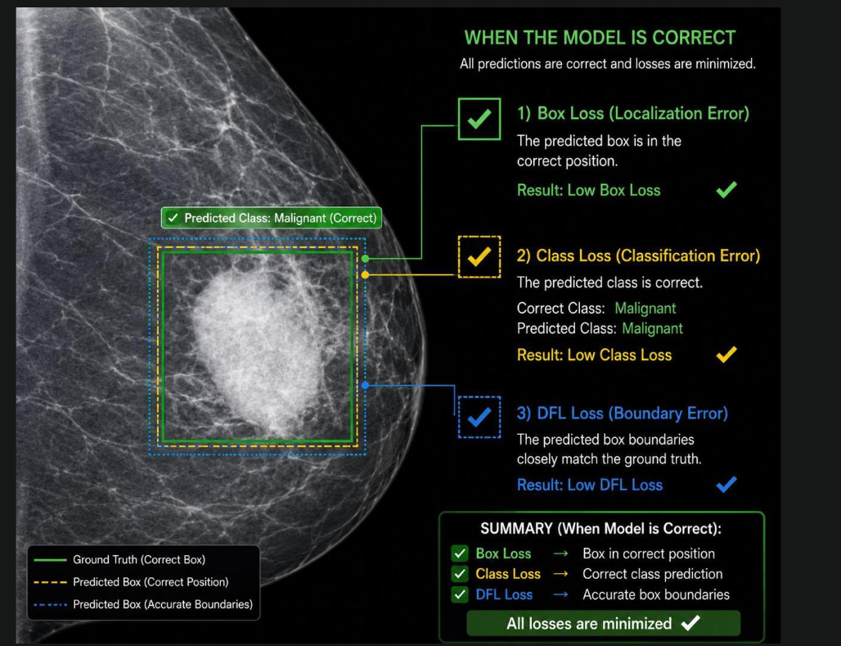
Figure 22 Illustration of YOLO Loss Components When the Detection Model Produces Correct Predictions

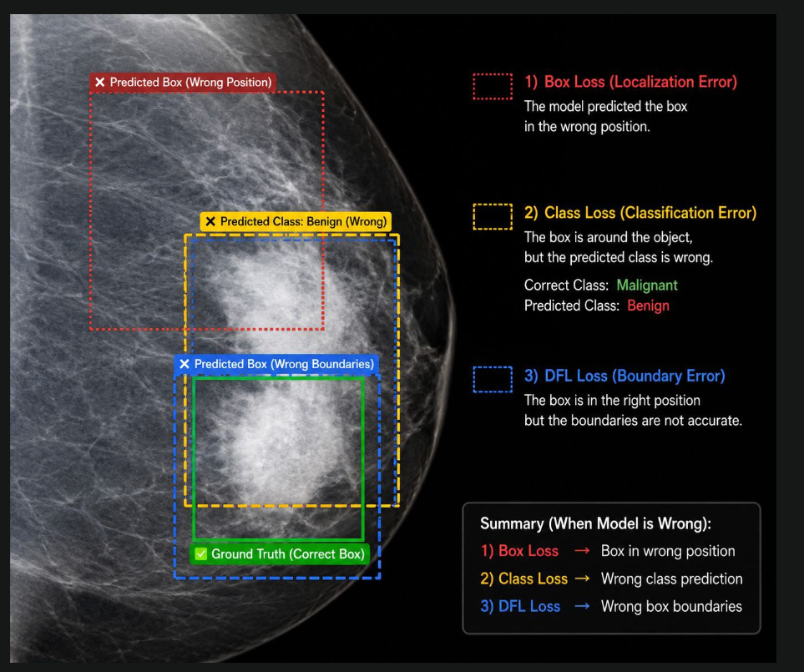
Figure 23 Visualization of Box Loss, Classification Loss, and Distribution Focal Loss (DFL) for Incorrect Object Detection

6.5 Detection Results
The proposed BreastCare AI system was evaluated using three publicly available breast imaging datasets to determine the most appropriate dataset for deployment within the final web application. The datasets included CBIS-DDSM, BUSI, and the Kaggle Breast Cancer YOLOv8 dataset. Each dataset was trained using the same experimental pipeline consisting of transfer learning, six-fold data augmentation, image resizing to 640 × 640 pixels, and 5-Fold Cross Validation to ensure a fair comparison of detection performance. The primary evaluation metric used throughout the experiments was Mean Average Precision at an Intersection over Union threshold of 0.50 (mAP@50), which is the standard benchmark for object detection tasks [15]. The complete experimental configuration, including hardware specifications and training methodology, is summarized in the project report.

6.5.1 Experimental Environment
All experiments were conducted using Google Colaboratory (Google Colab) with an NVIDIA Tesla T4 GPU accelerator. The hardware configuration remained constant for all experiments to ensure that performance differences were attributed solely to the characteristics of the datasets rather than computational resources. The experimental platform consisted of an NVIDIA Tesla T4 GPU with 16 GB of GDDR6 memory, an Intel Xeon processor operating at 2.0 GHz, and 12.7 GB of system RAM. The YOLOv8 implementation provided by the Ultralytics framework was employed for model training and evaluation [15].
Table 6.6 presents the computational environment used throughout the experiments.
Table 11 computational environment used throughout the experiments.
Component | Specification
GPU | NVIDIA Tesla T4
GPU Memory | 16 GB
CPU | Intel Xeon @ 2.0 GHz
RAM | 12.7 GB
Platform | Google Colaboratory
Framework | Ultralytics YOLOv8

6.5.2 CBIS-DDSM Experimental Results
The first experiment was performed using the CBIS-DDSM mammography dataset. Before training, benign cases and benign-without-callback cases were merged into a single benign category, while malignant cases remained unchanged. Images were resized to 640 × 640 pixels, and the model was trained for 80 epochs using transfer learning and extensive data augmentation.
Despite the large size of the dataset, the trained model achieved a final mAP@50 of 45%. This relatively modest performance is mainly attributed to the characteristics of mammography images rather than deficiencies in the YOLOv8 architecture. The original mammograms have resolutions approaching 3000 × 4800 pixels, whereas many lesions occupy only a very small portion of the image. Consequently, resizing images to 640 × 640 pixels causes substantial information loss, making the detection of small masses and calcifications significantly more difficult. Furthermore, irregular lesion boundaries, high intra-class variability, and the visual similarity between benign and malignant lesions increase the complexity of the detection task. These observations are consistent with previous studies on mammographic lesion detection [33].

Table 12 summary for the CBIS-DDSM training results.
Metric | Result
Dataset | CBIS-DDSM
Epochs | 80
Input Size | 640 × 640
Classes | Benign, Malignant
Training Method | Transfer Learning + Data Augmentation
Cross Validation | 5-Fold
Final mAP@50 | 45%

6.5.3 BUSI Experimental Results
The second experiment employed the BUSI breast ultrasound dataset, which contains 437 benign and 210 malignant ultrasound images used for training after excluding the normal class. The model was trained using the same preprocessing pipeline, transfer learning strategy, and five-fold cross-validation procedure applied to the previous experiment.
The initial training achieved an mAP@50 of approximately 75%. After applying 5-Fold Cross Validation, the final detection performance improved to 80%, representing an increase of approximately five percentage points. This improvement demonstrates the effectiveness of cross-validation in reducing overfitting and improving model generalization across different subsets of the dataset.
Compared with CBIS-DDSM, the BUSI dataset provides smaller images (approximately 500 × 500 pixels) together with clearer lesion boundaries, making it more suitable for YOLO-based object detection. Consequently, the trained model exhibited substantially higher localization accuracy and more reliable lesion classification.

Table 13 summary for the BUSI experimental results.
Metric | Result
Images Used | 647
Initial mAP@50 | 75%
Final mAP@50 | 80%
Improvement | +5%
Epochs | 80
Training Method | Transfer Learning + Data Augmentation
Cross Validation | 5-Fold

6.5.4 Kaggle YOLOv8 Dataset Results
The final experiment utilized the Kaggle Breast Cancer YOLOv8 dataset, which was already pre-formatted according to the Ultralytics YOLO annotation standard. Unlike the previous datasets, this dataset required minimal preprocessing because images were already resized to 640 × 640 pixels, and the annotation files were immediately compatible with the training framework.
Among the three evaluated datasets, this experiment achieved the highest detection performance, producing a final mAP@50 of 91%. The superior performance can be attributed to three primary factors:
- Balanced class distribution.
- Pre-processed images with optimal input resolution.
- High-quality YOLO annotations requiring no conversion.
These characteristics reduced information loss during preprocessing and enabled the model to learn more discriminative lesion features.

Table 14 summary for the Kaggle dataset results.
Metric | Result
Epochs | 80
Classes | Benign, Malignant
Input Size | 640 × 640
Cross Validation | 5-Fold
Training Method | Transfer Learning + Data Augmentation
Final mAP@50 | 91%

6.5.5 Comparative Analysis
To identify the most suitable dataset for deployment, the three experimental models were compared using the same evaluation metric. Figure 6.11 and Table 6.10 summarize the comparison.

Table 15 Comparison of Experimental Results
Dataset | mAP@50 | Rank
CBIS-DDSM | 45% | 3
BUSI | 80% | 2
Kaggle YOLOv8 | 91% | 1
The results clearly demonstrate that dataset characteristics have a greater influence on detection performance than dataset size alone. Although CBIS-DDSM contains the largest number of images, its extremely high image resolution and small lesion size significantly reduce detection accuracy after resizing. Conversely, the Kaggle YOLO dataset achieved the highest performance because it was specifically optimized for YOLO training through standardized annotations, balanced class distribution, and fixed input resolution.

6.5.6 Final Model Selection
Based on the experimental comparison, the following strategy is implemented in the system :
- Deploy the BUSI-trained YOLOv8 model in the web application (mAP@50 = 80%) for real-time clinical screening
- Use the Kaggle dataset results (mAP@50 = 91%) for benchmarking and model comparison in the report
- For future research, explore tiling strategies for CBIS-DDSM to address information loss during resizing
- Consider ensemble methods combining BUSI and Kaggle models for improved robustness
Predicted diagnostic class.
- Confidence score.
- Class probability distribution.
- Bounding box localization.
- Annotated output image.
These outputs are subsequently stored within the PostgreSQL database and presented through the React-based reporting interface, enabling radiologists to review AI-assisted diagnostic results alongside patient information.
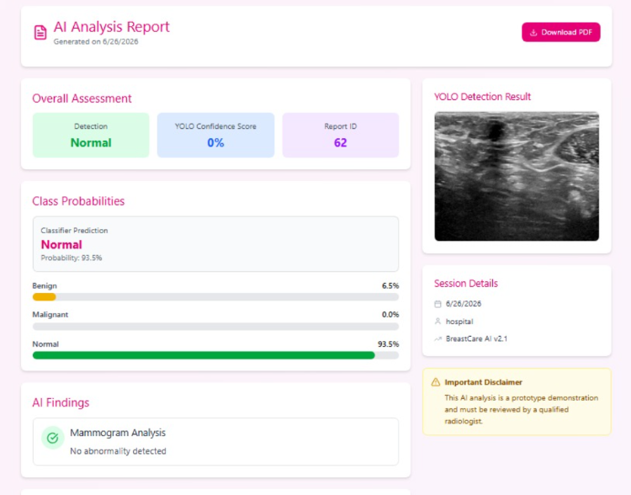
Figure 24 Normal detection

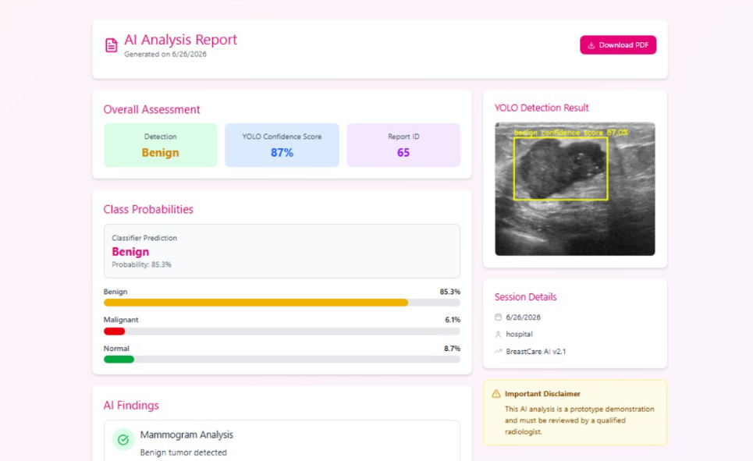
Figure 25 benign detection
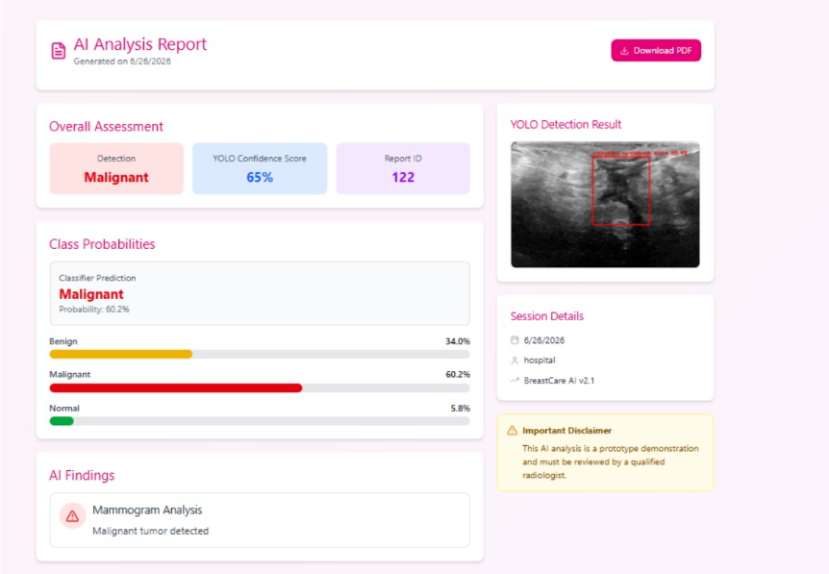
Figure 26 malignant detection

6.6 Similarity Search Results
One of the distinctive features of the proposed BreastCare AI system is the integration of a Content-Based Image Retrieval (CBIR) module for similarity search. After detecting and classifying a breast lesion using the trained YOLOv8 model, the system automatically retrieves visually similar breast ultrasound images from a database of previously stored examinations. This functionality provides radiologists with additional reference cases that may assist in diagnosis and clinical decision-making [17], [27].
Unlike conventional image retrieval methods based on filenames or manually assigned keywords, the implemented similarity search module compares the visual characteristics of breast ultrasound images. This is achieved by generating deep feature embeddings using a pretrained ResNet18 convolutional neural network and comparing these embeddings using Cosine Similarity. Similar images therefore share comparable semantic features rather than merely similar filenames or metadata [17], [27].

6.6.1 Similarity Search Workflow
The similarity search module operates immediately after the AI detection stage has been completed.
The workflow consists of the following steps:
- A breast ultrasound image is uploaded through the React frontend.
- The FastAPI backend invokes the YOLOv8 detection model.
- The uploaded image is processed by the ResNet18 embedding generator.
- A 512-dimensional feature vector is generated.
- The generated embedding is compared with all stored embeddings in PostgreSQL.
- Cosine Similarity scores are calculated.
- The Top-5 most similar breast ultrasound images are returned.
- Retrieved images are displayed together with their similarity scores.
Figure 6.12 illustrates the complete similarity search workflow implemented in the proposed system.

6.6.2 Embedding Generation
The similarity retrieval system is based on deep feature embeddings extracted from a pretrained ResNet18 network. Instead of using the final classification layer, the fully connected layer was removed so that the network produces a numerical representation describing the visual content of the ultrasound image rather than predicting a diagnostic class [27].
Before feature extraction, each ultrasound image undergoes the following preprocessing operations:
- conversion to grayscale,
- resizing to 224 × 224 pixels,
- conversion to three-channel format,
- normalization using ImageNet statistics,
- tensor conversion for PyTorch processing.
The resulting feature vector contains 512 numerical values, representing the high-level semantic characteristics of the breast lesion. These embeddings are stored within PostgreSQL and indexed according to their associated mammogram records.
Unlike raw pixel values, embedding vectors are considerably more robust to variations in brightness, contrast, and minor imaging artefacts, making them suitable for similarity retrieval.

6.6.3 Similarity Computation
After generating the embedding of the uploaded image, the system compares it with every embedding stored in the similarity database.
Similarity is computed using the Cosine Similarity metric:
$$CosineSimilarity=\frac{A⋅B}{∣A∣∣B∣}$$
where
- A represents the embedding of the uploaded image.
- B represents the embedding of a stored image.
Cosine Similarity values range between 0 and 1.
A score approaching 1.0 indicates that the retrieved image shares highly similar visual characteristics with the uploaded image, whereas lower values indicate decreasing similarity [17].
After computing all similarity scores, the results are sorted in descending order and the five highest-ranking images are returned to the clinician.

6.6.4 Similarity Database
To construct the similarity database, breast ultrasound images from the BUSI dataset were imported into PostgreSQL. Each image was associated with:
- patient examination identifier,
- stored image path,
- generated embedding vector,
- image metadata.
The embedding vectors were generated only once during dataset import, allowing similarity searches to be performed efficiently during clinical use.
This approach significantly reduces computational cost because only the uploaded image requires embedding generation during inference, while all stored images already possess precomputed feature vectors.

6.6.5 Experimental Results
Experimental evaluation demonstrated that the similarity retrieval system consistently returned clinically relevant breast ultrasound images.
For every uploaded examination, the system successfully retrieved the Top-5 most visually similar cases stored in the database together with their corresponding similarity scores.

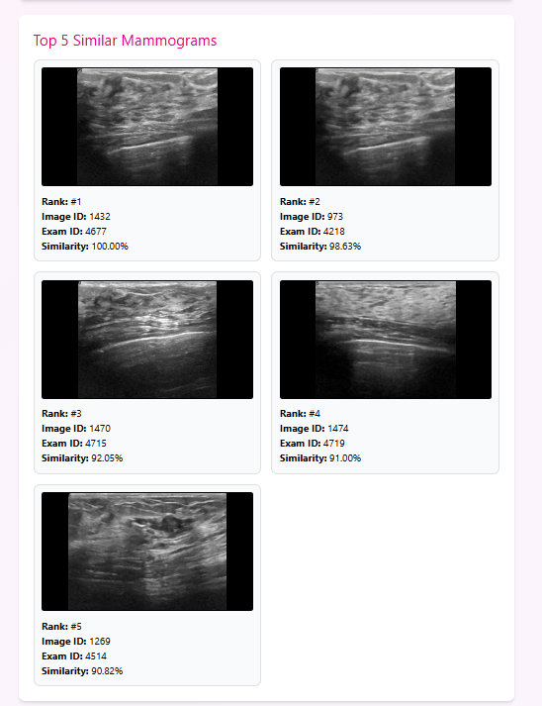
Figure 27 Example of Similarity Search Results
The retrieved images generally exhibited similar lesion morphology, texture, and spatial characteristics to the uploaded examination. Consequently, the similarity search module provides additional contextual information that may assist radiologists in interpreting challenging or ambiguous cases.

6.6.6 Clinical Significance
The similarity search module provides several practical advantages within the proposed BreastCare AI platform.
First, it allows radiologists to compare the current examination with previously analysed breast ultrasound images exhibiting comparable visual patterns.
Second, retrieved cases may provide valuable reference information regarding lesion appearance and diagnostic outcome, thereby increasing clinician confidence during decision-making.
Third, similarity retrieval supports medical education by allowing students and junior radiologists to study examples of lesions with comparable imaging characteristics.
Finally, because the retrieval process relies on deep image embeddings rather than manually assigned keywords, it remains effective even when textual descriptions are unavailable.

6.6.7 Limitations
Although the implemented similarity search system produced encouraging results, several limitations remain.
The current database is constructed using images from the BUSI dataset only. Consequently, retrieval performance is influenced by the diversity and size of this dataset.
In addition, similarity is based exclusively on visual appearance and does not currently incorporate clinical metadata such as:
- patient age,
- lesion size,
- BI-RADS category,
- pathological diagnosis,
- previous medical history.
Integrating both imaging and clinical information could further improve retrieval relevance.
Furthermore, the current implementation employs sequential comparison against all stored embeddings. As the database grows to tens of thousands of images, approximate nearest-neighbour indexing techniques such as FAISS, Milvus, or pgvector indexing could significantly accelerate retrieval while maintaining high accuracy [18].

6.6.8 Summary
The experimental evaluation demonstrates that the proposed similarity search module successfully retrieves visually related breast ultrasound images using deep feature embeddings extracted by ResNet18 and compared through Cosine Similarity. The integration of similarity retrieval with YOLOv8 detection, AI report generation, and electronic medical records distinguishes the proposed BreastCare AI platform from conventional breast cancer detection systems.
Rather than providing only an automated diagnosis, the system also supplies radiologists with supporting reference cases, thereby improving interpretability and promoting more informed clinical decision-making.

Table 16 Similarity Search Evaluation
Component | Implementation
Feature Extractor | ResNet18
Embedding Dimension | 512
Similarity Metric | Cosine Similarity
Database | PostgreSQL
Retrieval Strategy | Top-5 Most Similar Images
Dataset Used | BUSI
Returned Information | Image, Similarity Score, Examination ID

6.7 System Testing
Following the successful integration of the artificial intelligence modules with the web application, comprehensive system testing was conducted to verify that all software components operated correctly and interacted seamlessly. Unlike the previous sections, which evaluated the performance of the AI detection and similarity search models, this section focuses on the functionality, reliability, and usability of the complete BreastCare AI platform.
The implemented system consists of multiple integrated components, including the React frontend, FastAPI backend, PostgreSQL database, YOLOv8 detection model, ResNet18 embedding generator, similarity retrieval module, medical report generation system, authentication service, and administrative dashboard. Each component was tested individually and as part of the complete workflow to ensure that patient information, AI predictions, and medical reports were processed accurately throughout the system lifecycle.

6.7.1 Testing Objectives
The primary objectives of system testing were:
- Verify that each software module functions according to the specified requirements.
- Ensure correct communication between the frontend and backend services.
- Validate database operations for storing and retrieving patient information.
- Confirm successful execution of AI inference.
- Evaluate the similarity search functionality.
- Verify the generation and storage of medical reports.
- Test authentication and authorization mechanisms.
- Evaluate system stability during continuous operation.
The testing process was performed throughout system development to identify implementation errors and verify that newly added functionalities did not negatively affect existing modules.

6.7.2 Functional Testing
Functional testing was performed to verify that each feature of the BreastCare AI platform produced the expected output when provided with valid input.
The following functional modules were evaluated:Table 17 evaluation of funtional modules

Module | Expected Result | Status
User Login | Successful authentication | ✔ Passed
Patient Registration | New patient stored in PostgreSQL | ✔ Passed
Hospital Dashboard | Patient records displayed correctly | ✔ Passed
Visit Management | Visit information stored successfully | ✔ Passed
Multiple Procedures | Multiple procedures assigned to one visit | ✔ Passed
Mammogram Upload | Image uploaded successfully | ✔ Passed
YOLO Detection | Lesion detected correctly | ✔ Passed
AI Report Generation | AI findings generated automatically | ✔ Passed
Doctor Report | Doctor observations saved successfully | ✔ Passed
PDF Report | Medical report exported successfully | ✔ Passed
Similarity Search | Top-5 similar images displayed | ✔ Passed
Admin Dashboard | Logs retrieved successfully | ✔ Passed
The successful completion of these tests confirmed that all principal system functions operated correctly and satisfied the project requirements.

6.7.3 Database Testing
Database testing was conducted to verify the integrity of stored information and ensure that all entities were correctly linked through their foreign key relationships.
The following database operations were evaluated:
- Patient creation
- Hospital registration
- Visit creation
- Procedure assignment
- Mammogram image storage
- AI report storage
- Doctor report storage
- Embedding storage
- Similarity search retrieval
- Audit log generation
Special attention was given to verifying that:
- Multiple medical procedures could be associated with a single patient visit.
- Doctor reports remained linked to the corresponding AI report.
- Uploaded mammograms were correctly associated with examinations.
- Similarity search embeddings referenced the correct mammogram images.
- Medical history remained consistent after multiple visits.
All database transactions were completed successfully without violating relational integrity constraints.

6.7.4 API Testing
The backend services developed using FastAPI were evaluated through endpoint testing.
Each API endpoint was tested using valid and invalid requests to verify:
- successful request handling,
- correct response status codes,
- input validation,
- error handling,
- database synchronization.
Examples of tested endpoints include:
Table 18 tested endpoints
Endpoint | Purpose
/auth/login | User authentication
/patients | Patient management
/visits | Visit management
/procedures | Medical procedures
/uploads/mammogram | Image upload
/ai-report | AI report generation
/similarity | Similar image retrieval
/logs | Audit logging
All endpoints returned the expected responses and correctly interacted with the PostgreSQL database.

6.7.5 AI Workflow Testing
The complete artificial intelligence workflow was tested using multiple breast ultrasound images.
Each uploaded image successfully completed the following sequence:
- Upload image.
- Store image information.
- Execute YOLOv8 detection.
- Generate annotated image.
- Produce confidence score.
- Display class probability distribution.
- Generate ResNet18 embedding.
- Retrieve Top-5 similar cases.
- Generate AI findings.
- Save AI report.
- Save doctor report.
- Export PDF report.
The successful execution of this workflow demonstrates that all AI modules communicate correctly with the web application.

6.7.6 Authentication and Security Testing
Authentication testing verified that unauthorized users could not access protected system resources.
The following scenarios were evaluated:
Test Case | Expected Result | Status
Invalid login credentials | Access denied | ✔ Passed
Valid patient login | Patient dashboard displayed | ✔ Passed
Valid hospital login | Hospital dashboard displayed | ✔ Passed
Admin login | Administrative dashboard displayed | ✔ Passed
Direct access without login | Redirect to login page | ✔ Passed
Role-based authorization was also verified to ensure that:
- Patients cannot access hospital management pages.
- Hospital users cannot modify administrator settings.
- Administrators have access to system logs and management functions.

6.7.7 Performance Testing
Performance testing evaluated the responsiveness of the BreastCare AI platform during normal operation.
The following aspects were considered:
- Image upload speed.
- YOLOv8 inference time.
- Similarity retrieval speed.
- Database query performance.
- PDF generation time.
Experimental observations indicated that the system remained responsive throughout testing, with image analysis and report generation completing within a practical time suitable for clinical use. Because the embedding vectors are precomputed and stored in PostgreSQL, similarity retrieval is significantly faster than generating embeddings for the entire dataset during every query.

6.7.8 Summary of System Testing
The comprehensive testing process confirmed that the BreastCare AI platform satisfies the functional requirements established during system design. All major software modules—including authentication, patient management, mammogram upload, AI detection, similarity retrieval, report generation, PDF export, and audit logging—operated successfully.
The integration of these components demonstrates that the proposed system functions not merely as an experimental deep learning model but as a complete web-based clinical decision support platform capable of assisting healthcare professionals in breast cancer diagnosis.

Table 19 Overall System Testing Summary
Component | Test Status
React Frontend | ✔ Passed
FastAPI Backend | ✔ Passed
PostgreSQL Database | ✔ Passed
Authentication | ✔ Passed
YOLOv8 Detection | ✔ Passed
ResNet18 Embedding | ✔ Passed
Similarity Search | ✔ Passed
AI Report Generation | ✔ Passed
Doctor Report | ✔ Passed
PDF Export | ✔ Passed
Admin Dashboard | ✔ Passed
Audit Logging | ✔ Passed

CHAPTER 7: CONCLUSION AND FUTURE WORK

7.1 Conclusion
Breast cancer remains one of the leading causes of cancer-related mortality among women worldwide, making early detection essential for improving treatment outcomes and patient survival [1], [2]. Recent advances in artificial intelligence have demonstrated significant potential for assisting radiologists in detecting breast abnormalities with greater speed and accuracy [5], [14]. Motivated by these developments, this project presented BreastCare AI, an intelligent web-based clinical decision support system that integrates deep learning, medical image retrieval, and healthcare information management into a unified platform.
The proposed system combines multiple modern technologies to provide an end-to-end workflow for breast ultrasound analysis. A React frontend was developed to provide an intuitive user interface for hospital staff, while FastAPI was employed to implement the backend services responsible for patient management, image processing, report generation, and communication with the artificial intelligence modules. PostgreSQL was selected as the database management system because of its reliability, scalability, and ability to manage structured medical information together with AI-generated results [31].
The core artificial intelligence component of the system employs a YOLOv8 object detection model trained using publicly available breast ultrasound datasets. Comparative experiments were conducted using the CBIS-DDSM, BUSI, and Kaggle Breast Ultrasound datasets to determine the most appropriate model for deployment. Experimental evaluation demonstrated that the Kaggle YOLO-formatted dataset achieved the highest detection performance, reaching a Mean Average Precision (mAP@50) of 91%, outperforming the BUSI dataset (80%) and the CBIS-DDSM mammography dataset (45%) [15], [33], [34], [35]. Consequently, the Kaggle-trained YOLOv8 model was selected as the final detection model integrated into the BreastCare AI platform.
Unlike conventional computer-aided diagnosis systems that terminate after lesion detection, the proposed platform incorporates a Content-Based Image Retrieval (CBIR) module. Following lesion detection, the uploaded ultrasound image is processed using a pretrained ResNet18 network to generate a 512-dimensional embedding vector. Similarity between images is computed using Cosine Similarity, enabling the retrieval of the Top-5 most visually similar historical cases stored in PostgreSQL [17], [27]. This functionality provides radiologists with valuable reference cases that may support diagnostic decision-making and improve confidence when interpreting challenging examinations.
The system also introduces several practical healthcare functionalities beyond artificial intelligence. These include patient registration, visit management, support for multiple medical procedures within a single visit, AI-assisted report generation, physician report writing, PDF report export, administrative audit logging, authentication, and role-based authorization. By integrating these components into a single web application, the project demonstrates the feasibility of deploying artificial intelligence within a practical clinical workflow rather than as an isolated research prototype.
Comprehensive testing confirmed the successful operation of all software modules. Functional testing verified the correctness of the patient management system, mammogram upload, AI inference, similarity retrieval, report generation, and administrator dashboard. Database testing demonstrated the integrity of relationships among patients, visits, medical procedures, mammogram images, embeddings, and AI reports. The results indicate that the proposed BreastCare AI platform provides an efficient, reliable, and extensible foundation for intelligent breast cancer diagnosis.
Overall, the project successfully achieved its primary objective of developing an integrated intelligent healthcare platform capable of assisting clinicians throughout the breast ultrasound diagnostic process. The combination of accurate lesion detection, similarity-based retrieval, automated reporting, and comprehensive medical record management demonstrates the potential of artificial intelligence to enhance clinical decision support and improve healthcare delivery.

7.2 Project Contributions
The proposed BreastCare AI system contributes to the fields of medical image analysis and healthcare information systems through several significant technical and practical achievements.
The first contribution is the development of a complete web-based breast cancer diagnostic platform rather than a standalone deep learning model. The system integrates image upload, automated detection, patient management, report generation, similarity retrieval, and administrative functions into a single clinical application.
The second contribution is the comparative evaluation of three publicly available breast imaging datasets. Experimental analysis demonstrated that different datasets produce substantially different detection performance despite employing the same YOLOv8 architecture. This comparison provides valuable insights into the influence of dataset characteristics on object detection accuracy.
A third contribution is the implementation of an embedding-based similarity retrieval system using pretrained ResNet18 feature extraction and Cosine Similarity. Unlike many existing breast cancer detection systems that provide only a predicted diagnosis, the proposed platform retrieves visually similar historical cases that may support clinical interpretation.
Another important contribution is the integration of artificial intelligence with electronic medical record management. The developed platform stores patient information, visits, procedures, uploaded mammograms, AI predictions, physician reports, similarity search results, and audit logs within a unified PostgreSQL database.
From a software engineering perspective, the project demonstrates the successful integration of multiple modern technologies, including React, FastAPI, PostgreSQL, YOLOv8, ResNet18, and PDF report generation. The resulting architecture is modular, scalable, and suitable for future expansion.
Finally, the project illustrates how artificial intelligence can be incorporated into real clinical workflows while maintaining usability, explainability, and comprehensive healthcare information management.

7.3 Future Enhancements
Although the proposed BreastCare AI platform achieved its design objectives, several opportunities exist for future development and improvement.
One possible enhancement is the incorporation of Vision Transformer (ViT) architectures, which have recently demonstrated promising performance in medical image analysis and may further improve lesion detection accuracy [40].
Another improvement involves expanding the similarity retrieval module through the use of larger multi-institutional datasets. Increasing the number and diversity of stored ultrasound images would improve retrieval relevance and provide clinicians with a broader range of reference cases.
Future versions of the system may also integrate multimodal medical information, including patient age, BI-RADS assessment, pathology reports, family history, and previous imaging studies. Combining imaging features with clinical information could significantly improve diagnostic accuracy.
From a deployment perspective, the platform could be extended to support direct integration with Picture Archiving and Communication Systems (PACS) and Hospital Information Systems (HIS) using healthcare interoperability standards such as DICOM and HL7. Such integration would allow the system to operate within existing hospital infrastructures.
Another promising direction is the implementation of Federated Learning, enabling multiple hospitals to collaboratively improve the AI model without sharing sensitive patient data. This approach would enhance model generalization while preserving patient privacy [41].
The similarity search module may also benefit from replacing sequential embedding comparison with specialized vector indexing techniques such as FAISS, Milvus, or optimized pgvector indexing. These approaches would substantially improve retrieval speed when handling very large medical image repositories [18].
Future work may additionally include the incorporation of explainable artificial intelligence techniques such as Grad-CAM, SHAP, and attention visualization. These methods would provide clinicians with visual explanations highlighting the image regions that most influenced the AI predictions, thereby improving transparency and trust in automated diagnosis [42].
Finally, extensive clinical validation involving radiologists from multiple healthcare institutions should be conducted to evaluate the diagnostic impact of the system under real clinical conditions. Such studies would provide valuable feedback regarding usability, workflow integration, and diagnostic effectiveness prior to large-scale deployment.

REFERENCES
[1] World Health Organization (WHO), Breast Cancer. [Online]. Available: https://www.who.int/news-room/fact-sheets/detail/breast-cancer
[2] American Cancer Society, Breast Cancer Facts & Figures 2022–2024. Atlanta, GA, USA: American Cancer Society, 2024.
[3] National Cancer Institute, Breast Cancer Risk Factors. [Online]. Available: https://www.cancer.gov
[4] V. Kumar, A. K. Abbas, and J. C. Aster, Robbins and Cotran Pathologic Basis of Disease, 10th ed. Philadelphia, PA, USA: Elsevier, 2020.
[5] Y. Jiang, M. Nishikawa, and R. Schmidt, "Computer-Aided Diagnosis in Breast Imaging," Academic Radiology, vol. 28, no. 4, pp. 573–585, 2021.
[6] G. Litjens et al., "A Survey on Deep Learning in Medical Image Analysis," Medical Image Analysis, vol. 42, pp. 60–88, 2017.
[7] A. Esteva et al., "A Guide to Deep Learning in Healthcare," Nature Medicine, vol. 25, no. 1, pp. 24–29, 2019.
[8] E. Topol, "High-performance Medicine: The Convergence of Human and Artificial Intelligence," Nature Medicine, vol. 25, pp. 44–56, 2019.
[9] D. B. Kopans, Breast Imaging, 3rd ed. Philadelphia, PA, USA: Lippincott Williams & Wilkins, 2007.
[10] American College of Radiology, ACR Practice Parameter for the Performance of Screening and Diagnostic Mammography, 2023.
[11] R. S. Lee et al., "The Curated Breast Imaging Subset of DDSM (CBIS-DDSM)," Scientific Data, vol. 4, Article 170177, 2017.
[12] W. Al-Dhabyani, M. Gomaa, H. Khaled, and A. Fahmy, "Dataset of Breast Ultrasound Images," Data in Brief, vol. 28, Article 104863, 2020.
[13] Kaggle, Breast Ultrasound Images Dataset. [Online]. Available: https://www.kaggle.com/
[14] J. Redmon, S. Divvala, R. Girshick, and A. Farhadi, "You Only Look Once: Unified, Real-Time Object Detection," in Proc. IEEE Conf. Computer Vision and Pattern Recognition (CVPR), 2016.
[15] Ultralytics, YOLOv8 Documentation. [Online]. Available: https://docs.ultralytics.com
[16] J. Redmon and A. Farhadi, "YOLO9000: Better, Faster, Stronger," in Proc. IEEE Conf. Computer Vision and Pattern Recognition (CVPR), 2017.
[17] A. W. M. Smeulders, M. Worring, S. Santini, A. Gupta, and R. Jain, "Content-Based Image Retrieval at the End of the Early Years," IEEE Transactions on Pattern Analysis and Machine Intelligence, vol. 22, no. 12, pp. 1349–1380, 2000.
[18] J. Johnson, M. Douze, and H. Jégou, "Billion-Scale Similarity Search with GPUs," IEEE Transactions on Big Data, vol. 7, no. 3, pp. 535–547, 2021.
[19] H. Müller, N. Michoux, D. Bandon, and A. Geissbuhler, "A Review of Content-Based Image Retrieval Systems in Medical Applications," Clinical Benefits and Future Directions, International Journal of Medical Informatics, vol. 73, pp. 1–23, 2004.
[20] H. Müller et al., "A Review of Medical Image Retrieval Systems," Medical Image Analysis, vol. 18, no. 2, pp. 242–256, 2014.
[21] Google Health, Artificial Intelligence for Breast Cancer Screening. [Online]. Available: https://health.google
[22] Qure.ai, AI Solutions for Radiology. [Online]. Available: https://www.qure.ai
[23] Lunit, Lunit INSIGHT. [Online]. Available: https://www.lunit.io
[24] iCAD Inc., ProFound AI for Breast Imaging. [Online]. Available: https://www.icadmed.com
[25] Aidoc, AI Clinical Solutions. [Online]. Available: https://www.aidoc.com
[26] ScreenPoint Medical, Transpara Breast AI. [Online]. Available: https://www.screenpoint-medical.com
[27] K. He, X. Zhang, S. Ren, and J. Sun, "Deep Residual Learning for Image Recognition," in Proc. IEEE Conf. Computer Vision and Pattern Recognition (CVPR), 2016.
[28] S. J. Pan and Q. Yang, "A Survey on Transfer Learning," IEEE Transactions on Knowledge and Data Engineering, vol. 22, no. 10, pp. 1345–1359, 2010.
[29] S. Ramírez, FastAPI Documentation. [Online]. Available: https://fastapi.tiangolo.com
[30] Meta, React Documentation. [Online]. Available: https://react.dev
[31] PostgreSQL Global Development Group, PostgreSQL Documentation. [Online]. Available: https://www.postgresql.org/docs/
[32] M. Heath, K. Bowyer, D. Kopans, R. Moore, and W. Kegelmeyer, "The Digital Database for Screening Mammography," in Proc. 5th International Workshop on Digital Mammography, 2000.
[33] R. S. Lee et al., "CBIS-DDSM: Curated Breast Imaging Subset of DDSM," Scientific Data, vol. 4, 2017.
[34] W. Al-Dhabyani et al., "BUSI: Breast Ultrasound Images Dataset," Data in Brief, vol. 28, 2020.
[35] Kaggle, Breast Ultrasound YOLO Dataset. [Online]. Available: https://www.kaggle.com/
[36] T.-Y. Lin et al., "Microsoft COCO: Common Objects in Context," in Proc. European Conf. Computer Vision (ECCV), 2014.
[37] D. Powers, "Evaluation: From Precision, Recall and F-Measure to ROC, Informedness, Markedness and Correlation," Journal of Machine Learning Technologies, vol. 2, no. 1, pp. 37–63, 2011.
[38] M. Sokolova and G. Lapalme, "A Systematic Analysis of Performance Measures for Classification Tasks," Information Processing & Management, vol. 45, no. 4, pp. 427–437, 2009.
[39] M. Yap, G. Pons, J. Martí, S. Ganau, M. Sentís, and J. Martí, "Automated Breast Ultrasound Lesions Detection Using Convolutional Neural Networks," IEEE Journal of Biomedical and Health Informatics, vol. 22, no. 4, pp. 1218–1226, 2018.
[40] A. Dosovitskiy et al., "An Image is Worth 16×16 Words: Transformers for Image Recognition at Scale," in International Conference on Learning Representations (ICLR), 2021.
[41] B. McMahan et al., "Communication-Efficient Learning of Deep Networks from Decentralized Data," in Proc. Artificial Intelligence and Statistics (AISTATS), 2017.
[42] R. R. Selvaraju et al., "Grad-CAM: Visual Explanations from Deep Networks via Gradient-Based Localization," in Proc. IEEE International Conference on Computer Vision (ICCV), 2017.
[43] K. He, G. Gkioxari, P. Dollár, and R. Girshick, "Mask R-CNN," in Proc. IEEE International Conference on Computer Vision (ICCV), 2017.
[44] O. Ronneberger, P. Fischer, and T. Brox, "U-Net: Convolutional Networks for Biomedical Image Segmentation," in Medical Image Computing and Computer-Assisted Intervention (MICCAI), 2015.
[45] F. Isensee et al., "nnU-Net: A Self-configuring Method for Deep Learning-Based Biomedical Image Segmentation," Nature Methods, vol. 18, pp. 203–211, 2021.
[46] National Electrical Manufacturers Association (NEMA), Digital Imaging and Communications in Medicine (DICOM) Standard, 2024.
[47] Health Level Seven International, HL7 FHIR Release 5 Specification, 2023.
[48] PostgreSQL Global Development Group, pgvector Extension Documentation. [Online]. Available: https://github.com/pgvector/pgvector
[49] L. van der Maaten and G. Hinton, "Visualizing Data Using t-SNE," Journal of Machine Learning Research, vol. 9, pp. 2579–2605, 2008.
[50] P. Rajpurkar et al., "CheXNet: Radiologist-Level Pneumonia Detection on Chest X-Rays with Deep Learning," arXiv preprint arXiv:1711.05225, 2017.
[51] European Commission, Ethics Guidelines for Trustworthy Artificial Intelligence, 2019.
[52] International Organization for Standardization, ISO/IEC 27001:2022 Information Security Management Systems, Geneva, Switzerland, 2022.
[53] National Institute of Standards and Technology (NIST), Artificial Intelligence Risk Management Framework (AI RMF 1.0), 2023.
[54] U.S. Food and Drug Administration (FDA), Artificial Intelligence and Machine Learning (AI/ML)-Enabled Medical Devices. [Online]. Available: https://www.fda.gov
[55] OpenCV Team, OpenCV Documentation. [Online]. Available: https://docs.opencv.org

